
Senior Project Report
Graphical User Interface for Robotic Path Planning

Student name: Amjad Aahed ID:U22106936
Student name: Ahmed Yacine ID:U22101195
Student name: Omar Abdlehamid ID:U22101281

Project Report for CS Junior Project
Computer Science
Supervisor: A/Prof Saber Elsayed

College of Computing and Informatics
University of Sharjah

November 2025

Abstract
Over the last decades, there has been an increase in the use of unmanned vehicles in a variety of applications. Most of those applications may contain obstacles in the environment that the robot needs to avoid safely. Consequently, research has focused on designing efficient navigation systems to traverse spaces with obstacles safely. However, there is not enough flexibility in the Graphical User Interface (GUI) that allows end users to specify the environments and path-planning algorithms to use to simulate real scenarios before deploying the robot in real scenarios. However, there is a lack of such GUIs in the literature. In addition, swarm-based navigation enables multiple autonomous agents to team up for complex environment navigation, which is a main characteristic of this project that makes it unique.
Therefore, this project aims to design a user-friendly interface that allows users (students, researchers, and practitioners) to specify the environment of interest, start and end targets and an algorithm that shows both the simulation process and results in real time. Different path planning algorithms, such as A*, Dijkstra, Depth-First Search (DFS), and Genetic Algorithms, will be implemented to achieve the best navigation. The GUI will provide the capability for both robot and swarm-based navigation planning with shepherding.
The adopted approach produces higher adaptability, particularly during emergencies such as fire evacuations, because it supports real-time decision processes alongside team-based mobility. The system will support 2D environment mapping with a dynamic map feature to reflect changes in real time.

The project works to solve three main problems of real-time functionality while handling dynamic obstacles more efficiently and reducing computations. The system is expected to achieve operational efficiency together with operational adaptability and safety through its integration of path planning algorithms, shepherding, and swarm-based navigation systems in robotics and industrial automation applications. The GUI will enable researchers, developers, and students to utilize a user-friendly platform that supports testing and optimization processes for diverse path-planning methods.

Table of Contents
Abstract .................................................................................................................................... 2
1. Introduction .......................................................................................................................... 7
1.1 Motivation ....................................................................................................................... 7
1.2 Gaps in Existing GUIs ..................................................................................................... 8
1.3 Justification for Algorithm .............................................................................................. 9
1.4 Project Description .......................................................................................................... 9
1.5 Project Aim and Objectives ............................................................................................. 8
1.6 Project Software and Hardware Requirements ............................................................. 10
1.7 Project Expected Output ............................................................................................... 10
1.8 Project Limitations ........................................................................................................ 11
1.9 Project Risk ................................................................................................................... 11
1.10 Organization of the Report .......................................................................................... 12
2. Problem Statement and Design Objectives ........................................................................ 15
2.1 Problem Statement and Proposed Solution ................................................................... 15
2.2 Design Objectives ......................................................................................................... 16
2.3 Design Constraints ........................................................................................................ 16
2.4 Design Assumptions ...................................................................................................... 16
2.5 Literature Review .......................................................................................................... 17
2.5.1 Overview of Path-Planning Techniques .................................................................. 17
2.5.2 A* Algorithm ........................................................................................................... 17
2.5.3 Dijkstra’s Algorithm ................................................................................................ 17
2.5.4 Depth-First Search (DFS) ........................................................................................ 18
2.5.5 Genetic Algorithm ................................................................................................... 18
2.5.6 Swarm Intelligence and Shepherding ........................................................................... 19
2.5.7 Comparative Summary of Similar GUI Systems .................................................... 20
2.5.8 Dynamic Map Integration and Real-Time Replanning ........................................... 20
3. Requirement Engineering and Analysis ............................................................................. 23
3.1 Stakeholders .................................................................................................................. 23
3.2 Functional Requirements ............................................................................................... 23
3.3 Non-functional Requirements ....................................................................................... 24
3.4 Use Case Diagram ......................................................................................................... 25
3.5 Constraints ..................................................................................................................... 25
4. Project Details .................................................................................................................... 27
4.1 Architecture and Environment ....................................................................................... 27
4.2 Implementation Issues and Challenges ......................................................................... 27
4.3 Deliverables ................................................................................................................... 27
4.4 Project Schedule and Timeline ...................................................................................... 28
4.5 System Design and Interaction Diagrams ..................................................................... 28
4.5.1 A* Pathfinding Algorithm Flowchart ...................................................................... 29
4.5.2 Dijkstra’s Algorithm Flowchart ............................................................................... 30
4.5.3 Genetic Algorithm Flowchart .................................................................................. 31
4.5.4 DFS Algorithm Flowchart ....................................................................................... 32
4.5.5 Shepherd Algorithm Flowchart ............................................................................... 32
4.5.6 UML Class Diagram ............................................................................................... 33
5. Implementation ................................................................................................................... 35
5.1 Hardware ....................................................................................................................... 35
5.2 Software ........................................................................................................................ 35
5.2.1 Entities ..................................................................................................................... 35
5.2.2 Functions ................................................................................................................. 35
5.2.3 Interfaces ................................................................................................................. 36
5.3 Integration ..................................................................................................................... 36
5.4 Code Figure ................................................................................................................... 37
6. Experiments ........................................................................................................................ 42
6.1 Black box Testing .......................................................................................................... 42
6.2 White-Box Testing ........................................................................................................ 42
6.3 Test Automation ............................................................................................................ 43
7. Results and Discussion ....................................................................................................... 46
7.1 Quantitative Analysis .................................................................................................... 46
7.2 Path Efficiency and Success Rate ................................................................................. 47
7.3 Graphical Analysis ........................................................................................................ 47
7.4 Screenshots of Test Scenarios ....................................................................................... 48
7.5 Test Cases ...................................................................................................................... 52
7.5.1 GUI Control Test Cases (Static2D/Dynamic2D) .................................................... 53
7.6 Comparative Performance Summary ............................................................................ 56
7.7 Discussion ..................................................................................................................... 56
7.8 Validation Table: Expected vs Actual Algorithm Performance ..................................... 56
7.9 Summary of Findings .................................................................................................... 57
8. Conclusion .......................................................................................................................... 59
9. References .......................................................................................................................... 61

Chapter I
Introduction

- Introduction
The industrial robotics market will experience a 175% expansion during the next decade according to Loup Ventures research on automation and intelligent systems development. The worldwide robotics industry will reach $43.32 billion in revenue by 2027 as world industries operate more than 3.4 million industrial robots now. A significant portion of industrial firms will dedicate no less than 25% of annual funding for automation innovations starting from this year and extending for five years. Industrial automation depends on swarm robotics technology, which represents around 40% of its current applications alongside defense applications at 25% and agricultural uses at 20% [14].

Swarm control now plays a vital role as it allows large-scale multi-agent systems to work together while adapting to changes found in dynamic environments. Swarm robotic applications extend across disaster rescue operations and military applications in addition to healthcare services and agriculture and warehousing operations. The real-time collaboration capability of swarm control systems in decentralized operations enables agents to carry out complex tasks like search and rescue missions along with supply delivery and area mapping activities in an expedited manner.

This project focuses on creating a path-planning interface that unites swarm control approaches with shepherding operations through a graphical user interface. Real-time algorithm testing and optimal path visualization become possible through an interactive Graphical User Interface (GUI) which the system offers to its users. Various known path-planning approaches, including A*, DFS, Dijkstra, and Genetic Algorithms, help produce obstacle-avoiding trajectories that support dynamic alterations in the environment dynamic map updates [1].

Swarm control strengthens the system’s practical operations because it allows multiple agents to work together for navigating challenging terrains while sharing decision-making responsibilities. Shepherding operates as a swarm control sub-component which directs agent groups to approach targeted objectives in safe and efficient ways [3][6]. The emergency response environment greatly benefits from this method because it needs adaptive intelligent guidance systems.

The project uses a user-friendly simulation platform to merge three components, including swarm control and shepherding, along with enhanced path-planning algorithms. The GUI facilitates real-time visualization, algorithm comparison, and interactive learning, making it suitable for academic and practical applications [2].

  - Motivation
The increasing use of autonomous systems in robotics, logistics, and autonomous vehicles highlights the necessity for new path-planning solutions that improve speed and user adaptability. Path-planning methods with traditional techniques do not present real-time visualizations, which prevents users from understanding their navigation plans in an effective manner. The design of an intuitive GUI enhances user experience because it provides easy interaction with path-planning algorithms and results in a real-time fashion [2].
Swarm Control (i.e., Shepherding) emerge as an essential element in contemporary robotic path planning because it provides adaptive, scalable navigation solutions for dynamic environments. Traditional single-agent navigation operates differently because swarm-based approaches harness collective intelligence, which allows multiple agents to work together while responding to current environmental alterations. The Swarm control system enables agents to move together efficiently, while Shepherding allows designated agents to lead others toward their targets for maximum navigation performance. Research demonstrates that these approach techniques provide critical value during emergency responses to guide teams securely with real-time coordination through changing and unexpected environments [3], [6].
This project is also stressing how important dynamic maps are, where the environment is updated in real time as obstacles and conditions change. The combination of dynamic mapping is favourable for system adaptability and suitability to complex and uncertain environments.
University of Sharjah uses this project as an important educational instrument and research platform, which demonstrates path-planning algorithms alongside swarm behaviours in a real-time visual format. The system becomes more useful for advanced robotic applications after expanding its functionality, as it provides answers for handling complex environmental conditions. Swarm Control in combination with Shepherding and Genetic Algorithms allows the system to become adaptable, thus suitable for application in emergency response planning alongside industrial automation that requires collective decision-making success [1], [3].
The project targets the union of theoretical investigations and practical implementation by delivering a flexible, interactive, and scalable path planning solution that serves academic and industrial.
  - Gaps in Existing GUIs

Although a range of robotic path-planning simulators are available, there are still major loopholes in the available GUIs to path-planning and swarm control. Most of the existing interfaces are either agent-centred on navigation matters or not horse of real-time dynamism in the map. They also do not combine various algorithms to make comparison in the same environmental conditions. Current GUIs typically provide minimal viewing of multi-agent coordination, a lack of user interactivity (manipulation of obstacles), and a lack of flexibility to changing environmental information. Conversely, this project proposes a single unified GUI, which fuses A, Dijkstra, DFS, and Genetic Algorithms alongside Shepherding-based swarm control as a simulation of both fixed and dynamic conditions that will be portrayed in real-time with graphical feedback. This fills the existing gap in terms of the educational, industrial, and research-oriented path planning instruments.

  - Justification for Algorithm

The selection of A*, Dijkstra, the DFS and Genetic Algorithms was chosen to reflect a balance between deterministic and the heuristic-based planning techniques.

- A* has been chosen because it is very efficient in producing optimum paths based on heuristic analysis and at the same time the computational overhead is less compared with other algorithms and can be used with static maps.
- Dijkstra's Algorithm offers guaranteed shortest-path computation and serves as a baseline deterministic algorithm for benchmarking.
- Depth-First Search (DFS) was also added since it is simple and a good learning experience, and a type of exploration related search behaviour used as a model to examine uninformed search behaviour.
- GA was incorporated to manage dynamic and uncertain environment where adaptive optimization must take into consideration that obstacles and conditions evolve.

The meaning of these algorithms or the combination is a balanced testbed of examining trade-offs of speed, accuracy and adaptability of the path-planning systems.

  - Project Description

The main goal of this project is to create an interactive user-friendly graphical user interface for robotic path planning that implements efficient navigation algorithms. Through the interface users have capabilities to determine environments while specifying start and end points along with adding obstacles before visualizing the computed paths using chosen path-planning approaches. The system leverages A*, Dijkstra, DFS, and Genetic Algorithms, which provide its ability to tackle navigation obstacles in numerous terrains [4].

The key element of this system enables swarm control functionality that permits various autonomous agents to form adaptive partnerships when responding to environmental changes. The swarm control system uses shepherding as a guidance method that directs robotic agents toward their targets by minimizing collisions while maximizing resource efficiency [3]. The approach delivers significant benefits for systems that need coordinated motion control and finds use in industrial operations, emergency responses, and search and rescue tasks [6].

The system interface will enable users to monitor algorithm performance in real time through interactive display elements that permit immediate parameter changes. It will also include support for dynamic maps so that route recalculation for changes in appearance of obstacles or conditions can occur. The system gives research and development professionals a strong tool to test and optimize path-planning approaches across multiple application areas [1].

  - Project Aim and Objectives

The main objective of this work involves creating an interactive robotic path planning graphical user interface which allows users to specify environments while letting them execute algorithms and view dynamic navigation paths. The proposed system will use Swarm Control and Shepherding methods to enable efficient collaboration among multiple agents during dynamic operations. The specific objectives include:

- Users should be able to use an easy-to-understand GUI interface which enables the definition of obstacles and navigation point setup while showing real-time path generation.
- The implementation of A*, Dijkstra, DFS, and Genetic algorithms generates flexible path-planning solutions according to [4], [5].
- Swarm Control technology will drive improvements to multi-agent coordination along with adaptability factors in complex environments [7].
- The research applies Shepherding methods to enhance robot swarm guidance performance when navigating towards specified targets [3].
- The system achieves extended applicability for different scenarios such as robotics, logistics, and emergency evacuation through its 2D path planning capabilities with dynamic map updates [6].

  - Project Software and Hardware Requirements
- Software Requirements:
Programming Language: Python
Libraries/Frameworks: Tkinter, Pil, ttk, OpenCV, NumPy, Matplotlib, SciPy, heapq, threading, math, random
Path-Planning Algorithms: A*, DFS, Dijkstra and Genetic algorithms
Swarm Control Algorithms: Shepherding-based swarm navigation techniques

- Hardware Requirements:
CPU: Intel Core i5/i7 or equivalent
RAM: 8GB minimum (16GB recommended for large-scale simulations)
GPU: Optional (for advanced 3D visualization)
Robotic Simulation Environment: ROS (Robot Operating System) – Optional for future expansion.

  - Project Expected Output

- A fully functional GUI for robotic path planning with real-time visualization capabilities.
- Integration of Swarm Control and Shepherding for efficient multi-agent navigation.
- A dynamic map should be supported so that the system can adjust to the changes in the surrounding and provide updated paths.
- Implementation of A*, Dijkstra, DFS, and Genetic Algorithms for flexible path-planning solutions.
- The functionality contains performance metrics intended to assess algorithm efficiency along with execution time and adaptability characteristics.
- The platform accepts 2D path planning formats, which extend its capabilities to multiple industrial sectors.

  - Project Limitations

The project implementation entails various limitations which shape the current scope. Over others, due to time and resource limitations, there was disqualification in use of higher order path-planning algorithms like Rapidly Exploring Random Tree (RRT) and generic evolutionary algorithms. The current model can only work in two-dimensional (2D) settings and not in three dimensions (3D) which is path planning. Even though the design framework is modular and can be extended in future, the current release focuses on most of the 2D maps, which helps in guaranteeing stability and reliability.

The other weakness is the complexity of calculations of some algorithms. Although it has successfully been or is being applied with Genetic Algorithms, they require a considerable amount of parameter sensitivity, including population size, mutation rates etc., that can have an impact on their run time in large maps. Besides, currently, the system has only been tested in a simulation setting, without the use of actual robots and thus issues like latency and sensor noise in real-life setting were not evaluated. This was because these limitations were a necessary trade-off that allowed them to concentrate on a useful platform with A, Dijkstra, DFS, Genetic Algorithms, swarm control, shepherding and dynamic maps, and have more advanced facilities and physical integration left to the next stage of development.

  - Project Risk

The project is associated with the risks of technical, schedule and product nature. Technical risk involves the computational intensity of Genetic Algorithms, which can necessitate schizophrenic ambience of population size, frequency rates of mutations and convergence requirements to surmount undue delays in real-time atomization’s [13]. There are the problems of shepherding: when properly adjusted the parameters of guidance (e.g., the radius of influence, relationships between the leaders and the followers or the weights of the guide), the shepherd agents might turn out to be unable to guide the swarm successfully or exaggerate control over the group, resulting to oscillations, collisions, and delays in goal satisfaction [6], [9]. The misalignment of swarm behavior with dynamic map input/output is also a possibility and in an environment that requires quick agent adaptation to new sudden environment changes like when new obstacles occurred [7], [8].

The schedule risks are caused by a limited formation period at which the introduction of 3D-based navigation and other algorithms had to be omitted to strict adherence to the necessary 2D-based framework within a set timeframe [5]. Further delays in testing or integration might also decrease the time to optimize swarm and shepherding behaviors which may lead to these features being in an optimized form by the end of the submission.

There are product risks in system stability, scalability and usability. Very big dynamic maps with a high count of agents can lead to a decrease in the speed of reaction, which will influence real time display and the accuracy of making decisions [1], [2]. Other performance bottlenecks that the GUI can face include simultaneous updates that re-plan several paths simultaneously whilst keeping visualization readable [4]. An additional risk is shepherding self: in case the user turns out to use and/or misinterpret shepherding controls, the social behavior of the swarm may go riotous, sequestering system effectiveness and trustworthiness [6].

Simple grid representations, software-complete, and incremental testing of functionalities were the solutions that the project embraced to counter the risks [2][4]. The application of parameter tuning and small-scale experiments were conducted to reduce likelihood of shepherding instability [9]. These measures will have an impact in ensuring that in case complications arise in one of these modules, the rest of the system will not collapse. Mitigation strategies are also enforcement strategies in the long term that involve optimization of Genetic Algorithms computations [13], tweaking shepherding parameters with adaptive strategies [6] and ramping to hardware integration to aid reliance on fully simulation results [3], [7].

  - Organization of the Report

The report is organized as follows. Chapter 1 begins with an introduction to the project which demonstrates why robotic path planning and swarm control has become important for modern autonomous systems. The section explains both the rationale for conducting the work and describes the project requirements together with an in-depth account of the system design. The section explicates the necessary software elements as well as hardware specifications while defining output requirements for the GUI-based simulation platform that handles 2D path planning applications with dynamic map support, integrating Swarm Control, Shepherding, and Genetic Algorithms.

The problem description in Chapter 2 provides an overview of the real-world challenges this system is intended to address. It includes the formal problem statement, proposed solution, design goals, existing constraints, and assumptions made throughout the project. This chapter also references relevant literature and research to justify the use of specific path-planning algorithms and swarm-based navigation approaches.

Chapter 3 focuses on the requirement of engineering and analysis. The documentation system specifies stakeholder responsibilities and displays a comprehensive layout of use cases with their action sequences and explains what features, functional needs, and non-functional expectations will be included in the system design. The document creates essential project constraints which developers must use for development together with deployment operations.

The report moves into project design details within Chapter 4. The system’s architectural design and operational settings together with technology selection are discussed. The chapter describes significant implementation obstacles facing the project while explaining what tangible outputs can be obtained through the development cycle.

The implementation procedure is presented in Chapter 5 alongside detailed specifications of hardware and software components. The chapter describes GUI internal organization along with visualization of algorithm execution and the modular methods for integrating Shepherding control strategies with swarm navigation coordination. The integration of Genetic Algorithms with A*, Dijkstra, and DFS is also presented as part of the path-planning solutions.

The experimental testing methodology for the system appears in Chapter 6 of the paper. The research design establishes evaluation approaches for assessing algorithm effectiveness as well as response quickness and collision prevention precision operating singly and within group operations. Evaluation approaches for swarm coordination, Shepherding effectiveness, and path planning efficiency on dynamic maps are included within this section.

Chapter 7 of the report will sum up the core findings and achievements of the project with possible outlines of the project development in the future. It assesses the performance of the existing system, analyzes its implementation and a discussion of the future work which includes real-time integration of hardware, further development of optimization measures, and expansion of the system to suit 3-D simulation in the advanced stages. Chapter 8 of this report contains all references from the entire document.

Chapter II
Problem Statement and Design Objectives
- Problem Statement and Design Objectives
This section describes the problem statement and design objectives.
- Problem Statement and Proposed Solution
There are multiple emergency scenarios including fires, earthquakes, and industrial accidents which present acute danger to human safety because these situations result in widespread public panic and disorder. Static emergency exit pathways with their accompanying signs lose effectiveness because of blockers, structural damage, or smoke clouds force operational changes in dynamic emergency situations. Active real-time evacuation assistance enables people to identify protected pathways while ensuring optimal route selection in such emergency circumstances.

The conventional robotic path-planning strategies limit their capabilities to predefined agent routes because they lack dynamic environmental response mechanisms. Their vulnerability in risky situations decreases their performance because quick adaptation stands crucial for safety. The main difficulty exists in designing a platform which efficiently regulates numerous autonomous agents while they navigate and respond to environmental changes in real time.

The proposed system creates a GUI which implements path-planning capabilities through Swarm Control combined with Shepherding to improve robotic navigation and emergency situational responses. The system implements A*, Dijkstra, DFS, and Genetic Algorithms for real-time dynamic optimal path computation that accounts for environmental modifications and dynamic maps.

Swarm Control allows two or more autonomous agents including drones and mobile robots to operate as a collective by distributing environmental information that results in coordinated movement adjustments. Through the shepherd management process, particular agents take responsibility for guiding other entities toward their targeted destinations to achieve efficient and secure navigation. Swarm intelligence enables the system to swiftly evaluate environmental conditions and detect the best escape routes as well as avoid obstacles in real time [3], [6].

The system enables users to interact through its GUI for designing space layouts, adding barriers, and showcasing navigation pathways in two-dimensional environments with dynamic updates. The application's UI makes it a crucial resource for emergency personnel, industrial automation, and academic researchers who obtain real-time analytical and decision capabilities.

The merger between Swarm Control and Shepherding enhances robotic path-planning efficiency through system implementations. The system delivers advanced adaptability and intelligence through its scalable solution which boosts safety operations and enhances resource management while ensuring a dependable wayfinding system in challenging environments [1], [3].

- Design Objectives
- The system requires the development of a user-friendly GUI which enables environment definition combined with the execution of programmed path-planning algorithms.
- The application implements A*, Dijkstra, DFS, and Genetic Algorithms to cover different navigation use cases [4], [5].
- The system should include Swarm Control and Shepherding features which will enhance its ability to adapt and enable cooperative movement and environment-responsive real-time responses [3], [6].
- The system provides instant visualizations and real-time monitoring of path-planning executions for better user decisions [2].
- The system must include dynamic map support to update the routes when obstacles appear and/or conditions change.

- Design Constraints
- Computational Efficiency: The system needs to run real-time path planning with minimal computation delays.
- Scalability: The interface requirements specify complete scalability across varied devices along with complete adaptability across different operational systems.
- Swarm Control Synchronization: The Swarm Control and Shepherding framework needs to establish seamless communication and coordination mechanisms between multiple autonomous agents for Swarm Control Synchronization [6].
- User Accessibility: Research along with developers must find the system interface approach accessible because it enables them to manage and change path-planning approaches smoothly [2].
- Algorithmic Balance: The selected path-planning algorithms need to find equilibrium between navigation precision and computational resource utilization to achieve optimal performance during dynamic environmental conditions [1].

- Design Assumptions
- The mapping of environmental conditions occurs properly before initiating path-planning procedures [4].
- Established that drones and autonomous agents possess dependable methods of communication and synchronization capabilities [6].
- A basic comprehension of path-planning basics and algorithm choice is required for users when they operate the GUI [2].
- A complete testing phase of the system takes place within controlled environments before deploying the system in unpredictable real-world scenarios [3].
- Active decision support from AI systems during emergency evacuations becomes possible through predefined risk factors which lead to time-efficient path optimization [1].

- Literature Review
    - Overview of Path-Planning Techniques
Path planning is an example of a rudimentary ability for autonomous devices to move robots from sources to targets in environments with obstacles in the way. Traditional algorithms A* and Dijkstra have essentially maintained their roles since they were first developed by Hart, Nilsson, and Raphael in 1968 and Dijkstra in 1959 for static environments. Dynamic emergency situations, however, demand adaptable and scalable solution methods as static situations are not enough.
Part of the combination of the heuristic systems and Genetic Algorithms which comprise the structure of the system, the review addresses two types of traditional and current techniques in an integrated manner: dynamic map update and swarm-intelligent techniques such as Shepherding and Swarm Control. With these methods, the system can adapt in real-time to changes in the environment so that safe and efficient navigation can be executed in dynamic scenarios.
    - A* Algorithm
A* (A-Star) represents a heuristic-based graph traversal and path search algorithm that finds widespread applications in robotic path planning. The algorithm determines the minimum path distance between two locations by calculating node accessibility costs alongside anticipated destination costs. The evaluation function is defined as f(n)=g(n) + h (n).
A* algorithm starts by placing the beginning node inside the open container that holds evaluation nodes, together with its own distinct closed node grouping for previously investigated nodes. Each iteration of the algorithm chooses the node featuring the minimum cost value f(n) = g(n) + h(n), with g(n) representing the precise cost from start to present node and h(n) representing the heuristic prediction of the goal distance. The algorithm terminates its operation to reconstruct the path when the present node becomes the target node. During its operation, the system reviews each adjacent node but omits obstacles along with previously tested nodes. The algorithm determines f(n) values of safe neighbouring nodes, then places them on the open list when they present improved or alternative paths. The algorithm continues its repetitive operations until it finds the goal node or reveals no solution while guaranteeing the optimum selection of paths when navigating obstructed areas [10].
    - Dijkstra’s Algorithm
A commonly applied approach for pathfinding, known as Dijkstra's Algorithm, determines shortest paths from a starting node to any other node inside graphs containing non-negative edge weights. It completes a uniform exploration of the search area by choosing nodes based on their cumulative lowest cost without heuristic information. The integrated GUI within this project enables Dijkstra’s algorithm to evaluate optimal paths in static 2D environments containing structured elements. The approach generates exact safe routes that swarm devices need when operators require exact coordination during emergency evacuations or industrial automation procedures.
The traditional application of Dijkstra's approach delivers good results, yet it requires significant computational time when operating in extensive environments with difficult mapping configurations [11]. presented algorithm improvements through direction biasing and grid segmentation techniques which according to the project requirements will optimize real-time swarm navigation performance. Dijkstra's optimal performance and dependable nature provide the system with its core functionality.
particularly during collaborative swarm-based planning operations that require predictable and easily interpretable systems [11].
    - Depth-First Search
The DFS algorithm performs uninformed graph traversal by traveling as deep as possible into each path until it requires backtracking through a stacked memory system (explicit or recursive). DFS starts at the root node by following one neighbour path until it achieves the goal or reaches an endpoint before it attempts unexplored adjacent neighbours. Users implementing DFS path planning on this project interface can view an agent conducting dynamic complete environment exploration without considering path efficiency in real time.
A strength of DFS lies in its ability to traverse expansive open areas but it lacks any assurance of picking the minimum path length because it can become stuck in lengthy branches across obstructed regions. Both its user-friendly nature and its easy-to-follow path exploration pattern make DFS a potent educational tool to display essential search behaviours in addition to its advanced algorithm counterparts within the system [12].
    - Genetic Algorithms
Genetic Algorithms is an optimization-based approach that has been inspired by natural selection and biological evolution. They are especially suitable for solving complex problems in path planning in dynamic environments where the traditional deterministic algorithms might fail [13].
The algorithm starts by creating a population of candidate paths, each of which takes the form of a sequence of points or moves. These candidate solutions are split on a fitness function, which measures various criteria such as the path length, safety margin from obstacles, and smoothness of motion.
Through a process of selection, one of the best performing possible candidate paths is selected to create the next generation. Crossover operations take parts of two parent paths to build new offspring paths, and replacement operations introduce randomness with the help of mutation operations to preserve diversity and explore the different solutions. During many generations the population moves towards more efficient paths that fit what is available in the environment.
One of the most important properties of Genetic Algorithms is that it can consider the dynamic maps, i.e. the obstacle or environmental conditions change during execution of the map. Unlike static algorithms, with Genetic Algorithms the populations can be re-evaluated and new solutions generated on the fly without restarting from the beginning of the entire planning process. This flexibility makes Genetic Algorithms particularly handy for emergency response scenarios and intricate industrial navigation tasks.
The algorithm terminates when the number of generations is reached, a convergence level is reached, or an acceptable path is found. Although Genetic Algorithms cannot define the mathematical shortest path, it offers nearly optimal and flexible and adaptable solutions in an otherwise hard environment for deterministic methods to navigate [13].
    - Swarm Intelligence and Shepherding
A decentralized network formed of numerous agents uses simple behavioral rules to interact locally until they achieve an overall purpose. The agents conduct standard operational protocols consisting of self-avoidance alongside connection enabling and team uniting mechanisms. The swarm achieves both quick environmental adaptation and efficient complex environment navigation through its basic local agent interactions.
Swarm development gains an essential addition through shepherding wherein leader agents act as guides for accompanying the others in the swarm. The system inaugurates its operation when it releases shepherd agents and regular agents throughout the environmental space. The swarm responds through local interactions, yet shepherd agents direct the group's movement by taking specific placement positions. The defined method enables swarming groups to achieve their targeted objectives as they navigate through space by preventing collisions and navigating obstacles.
This research implements both shepherding techniques and swarm intelligence through simulated dynamic multi-agent environment coordination programs. The shepherding technique receives enhancements from differential evolution which functions to optimize both leader agent movements and entire swarm movements [3]. The system reaches efficient adaptive navigation through this technique, making it suitable for crucial scenarios that require real-time decision-making including search-and-rescue operations or disaster response

    - Comparative Summary of Similar GUI Systems
System / Study | Year | Key Features | Limitations | Simulation Framework / Platform
ROS Navigation Stack | 2023 | Supports sensor fusion, real-time obstacle avoidance Uses costmaps and global planners (A *, DWA) | Complex setup, limited GUI interactivity; requires ROS knowledge | ROS2, Gazebo
MATLAB Robotics Toolbox | 2024 | Multiple built-in path-planning algorithms (A*, Dijkstra, PRM); provides visualization and trajectory tuning | Closed source; lacks swarm/shepherding behaviour simulation | MATLAB / Simulink
Webots Simulator | 2023 | Offers physics 3D engine, sensors on robots as well as dynamic display. | Limited runtime interactivity; high computational demand | Webots, ROS Integration
PyRobotics GUI | 2024 | Easily customizable, lightweight Python GUI with support of A* and Dijkstra, educational usage. | No support for dynamic map updates or multi-agent systems | Python / Tkinter
Proposed GUI System | 2025 | Real-time multi-agent simulation with shepherding control; supports dynamic maps and algorithm comparison (A*, Dijkstra, DFS, GA) | 2D-only prototype (future work: 3D & ROS2 integration) | Python (Tkinter, OpenCV, Matplotlib)
According to recent research, use of ROS2 and Gazebo as the standardized simulation frameworks is adopted to test swarm and path-planning algorithms in real time.
For instance:
- Liu et al. (2023) also came up with a context-sensitive shepherding model that incorporates ROS2 to guide swarm robots in cluttered space in real time.
- To increase the levels of agricultural robot adaptability, Sani et al. (2024) enriched the ROS2 navigation stack by powering it with dynamically changing cost-map information.
- Ahmad et al. (2024) came up with the idea of a decentralized UAV swarm navigation system named as PACNav and is supposed to operate in limited communication conditions.
- A hybrid Genetic-A-based path-planning with Python and RViz dynamic obstacle setting was proposed by Chen et al. (2025).
Such advances demonstrate a trend within the international community where robotic architectures are modular and simulation-based directly affecting the creation of our own GUI that combines the use of dynamic maps, swarm coordination and algorithm benchmarking in a single interface.
    - Dynamic Map Integration and Real-Time Replanning
The system involves an inbuilt dynamic map that keeps updating the agent of the environment in the process of navigating. As opposed to the fixed route generated by the traditional methods of static planning before the actual execution, the dynamic map will enable the agent to respond to the changes occurring in real time by rebuilding the environment on the move. This also allows stable and safe working conditions that could have not only stationary buildings but also temporary objects that might be present in the area.
The environment is discretized to the grid where free cells are denoted as traversable and occupied cells are denoted as restricted to calculate the navigable space. The registration of the obstacles is normally performed once during the initialization of the agent, and the corresponding dynamic obstacles are sensed in the perception range of the agent and added directly into the grid at the current instant of time. With every update cycle, a new local map is generated with the agent at its current location and immediate updates on the environment are always considered before making new decisions regarding the choice of the succession command to undertake.
Instead of having a global path planning, a plan is done incrementally. The agent will then search for all known adjacent cells that are within its visuals in what is known as a breadth search mechanism to find viable pathways to take. The travel cost is used to weight evaluation function with goal proximity to rank the nodes of a topology and this way the agent can choose the most promising direction of progression as well as ensure that no collisions occur. After picking an optimum frontier cell, a trace-back identification is performed to rebuild the short-term piece of the path, and this is implemented prior to this advancement cycle being activated again.
The combined dynamic map also allows the agent to keep in the direction of the goal, by continually switching between perception, map reconstruction and short horizon replanning and not obeying outdated assumptions. This design will reduce the chances of deadlock and enable the graceful redirection of the design in case of certain unforeseen events as well as enhance overall navigation resilience. The agent is not based on long-term forecast of obstacle motion, instead, it favors frequent sensing and quick regulation, which offers steadfast equilibrium of responsiveness and computation effectiveness.

Chapter III
Requirement and Analysis
- Requirement and Analysis
  - Stakeholders
- Primary Stakeholders:
- Emergency Responders: Benefit from real-time guidance and swarm-based navigational capability as both enable improved evacuation planning as well as disaster response task and the real-time solution includes Dynamic map support.
- Researchers and Developers Can conduct tests and optimize the swarm-based algorithms for efficient path planning algorithms like Genetic Algorithms using the system in controlled simulation environments.
- Industrial Automation Experts: Apply swarm control and shepherding for factory robotics and logistics automation.

- Secondary Stakeholders:
- Educational Institutions: Depending on the project, it is used for academic purposes for research work or interactive demonstration of swarm control, shepherding and path planning algorithms.
- Government & Safety Organizations: Use the system for urban safety planning with emergency routes optimizations with the help of the equivalent dynamic map features.
- AI & Robotics Communities: Actively use the technology for advancing AI-based path planning techniques as well as multi-agent collaborative coordination systems.

  - Functional Requirements

The essential features required by the project to achieve the proposed objectives include its functional requirements:
- FR1: The system will enable the users to create or upload their own custom versions of 2D maps as the navigation environment.
- FR2: The system will allow the users to set the start point and end point in path planning.
- FR3: The system will cater to obstacle management, which will enable the creation, removal and modification of existing obstacles during the implementation (both dynamic and static).
- FR4: The system will be dynamic whereby it updates the environment to capture real time changes on the map.
- FR5: The system will offer a wide variety of path-planning algorithms namely: A*, Dijkstra, DFS, and Genetic Algorithms, to compare the algorithms.
- FR6: The system will be based on swarm navigation that will allow more than one agent to be operating in the same environment at a particular time.
- FR7: the system will adopt shepherding methods whereby some of the agents, will lead to desired destination others.
- FR8: A real-time interactive GUI of the system shall provide visualisations of the navigation paths, swarm behaviour and shepherding.
- FR9: The system will record the performance outcomes (including the length of the path, time taken to execute the path, and the efficiency of the swarm) to be able to assess and compare them.
These requirements make sure that the platform takes care of functional ease to end-users as well as research capability to academic and experimental test.

  - Non-functional requirements
- Execution Qualities:
- Safety: The security infrastructure guarantees agents maintain safety by preventing accidents and selecting the best routes for cases demanding emergency responses including fire evacuations and disaster relief operations.
- Security: System security features limit unauthorized users from accessing system parameters to protect data integrity and block any possible poisonous modifications.
- Usability: The system delivers an easy-to-use graphical user interface which lets users interact in real time and makes the platform usable to both emergency teams and its developers and research community.
- Performance: Performance-based operations must deliver quick calculations along with immediate environmental response to achieve real-time path planning with dynamic map updates.

- Evolution Qualities:
- Testability: The modular design structure enables simple testing at both unit and integration levels which protects the system's stability when dealing with various use cases.
- Maintainability: The system works on clean architecture concepts which makes it easy to perform the maintenance activities using its codebase.
- Extensibility: The system could keep design features to support the implementation of new path planning methods (such as Genetic Algorithms) and robot platform integration capabilities.
- Scalability: Able to deal with an increasing number of autonomous agents without detrimental changes in performance tempo, including scalability for future expansions in larger-scale applications, like warehouse automation and city-scale evacuation planning.

  - Use Case Diagram
GUI robotic path planning
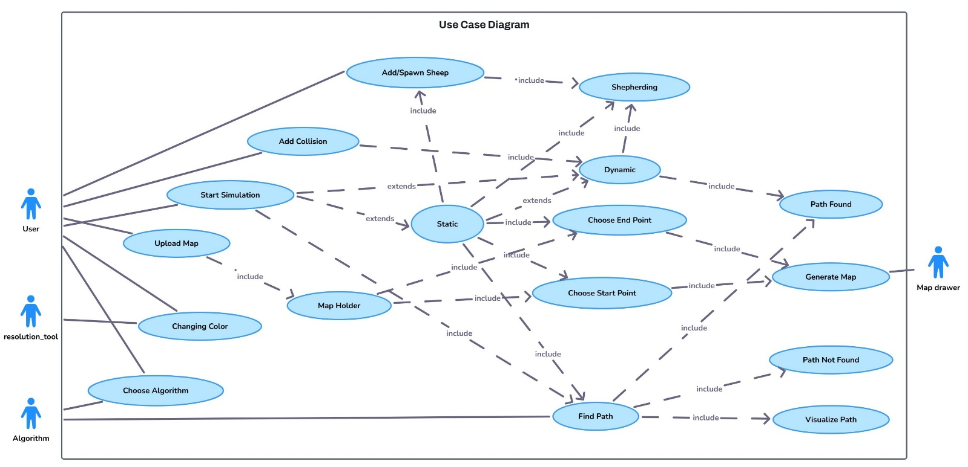

  - Constraints

- Computational Efficiency: The system needs to achieve maximum computational efficiency for minimized load during real-time operation.
- Hardware Dependency: The system demands drones together with robotic agents that possess hardware requirements strong enough to execute Swarm Control, Shepherding, and dynamic map updates.
- Environmental Mapping Accuracy: The accuracy of navigational procedures depends on the mapping precision of environmental areas during planning stages prior to execution and the reliability of dynamic maps during real-time updates.
- Network Synchronization: Swarm agents need reliable network connectivity to maintain real-time coordination through stable network channels for making timely movement adjustments.

Chapter IV
Project Details
- Project Details
  - Architecture and Environment
System software structured through modularity enables operators to scale their operations effectively. The GUI interface enables user interactions with all system operations where users can set start and end points while placing obstacles and selecting path calculations. The servers run algorithms that generate immediate graphical outputs that enhance the functional performance of the user interface. The present functionality produces 2D dynamic maps with static and moving obstacles to reflect real-time environmental changes [3].

Several autonomous agents team up using swarm-based navigation methods to cooperate in dynamic environment navigation tasks. Under swarm intelligence control this system enhances emergency decision making particularly during fire evacuation operations. Multiple drones and robots working together in these settings evaluate environments while avoiding obstacles as they generate optimal path sequences in real time. The emergency operational safety and operational efficiency improve through agents that use swarm-based navigation since it enables instant adjustments to blocked exits and changing conditions. Shepherding methods further strengthen swarm control by guiding groups of agents more efficiently toward their goals.

  - Implementation Issues and Challenges

The development process will produce different kinds of issues until completion. The central development challenge lies in achieving real-time execution because proper operation of Genetic Algorithms and swarm control demands sizeable processing resources for peak performance. Successful development of the GUI requires features for user interface design simplicity, user customization capabilities, and usability solutions integrated into the framework. The project requires algorithms for immediate path recalculation and dynamically handled obstacles through dynamic maps. Simultaneous navigation involves issues regarding visualizations, automatic collision warnings, and performance enhancement as well as independent coordination of autonomous agents. Emergency decision coordination represents an essential need for multiple agents because it maximizes their movements and minimizes accidents while adapting to encounter obstacles.
  - Deliverables

Implementation barriers will create multiple adverse effects on the project development stage. Requirements for solving processes will lead the project to its success. The main challenge of successful real-time operation lies in achieving implementation because Genetic Algorithms demand high computational capabilities to work efficiently. Robotics systems need rapid path planning since prolonged planning leads to environmental situations that generate undefined performance outputs. Two primary issues currently affect existing GUI design because it requires both easy usage for novice users and absolute user control modifications. The system requires immediate path re-planning methods together with obstacle handling algorithms which can adjust to environment modifications during system construction. The system employs Swarm Control with Shepherding based navigation methods for efficient emergency responses as a part of its operational safety approaches in industrial environments.

  - Project Schedule and Timeline
Figure 4.1: Gantt Chart
The timeline of the entire project and the milestones plan are depicted in the Gantt chart below that represents the stages of design, implementation, testing, and reporting.
  - System Design and Interaction Diagrams

System Flow Diagram Communication between GUI, Path Planner and Shepherding Controller:
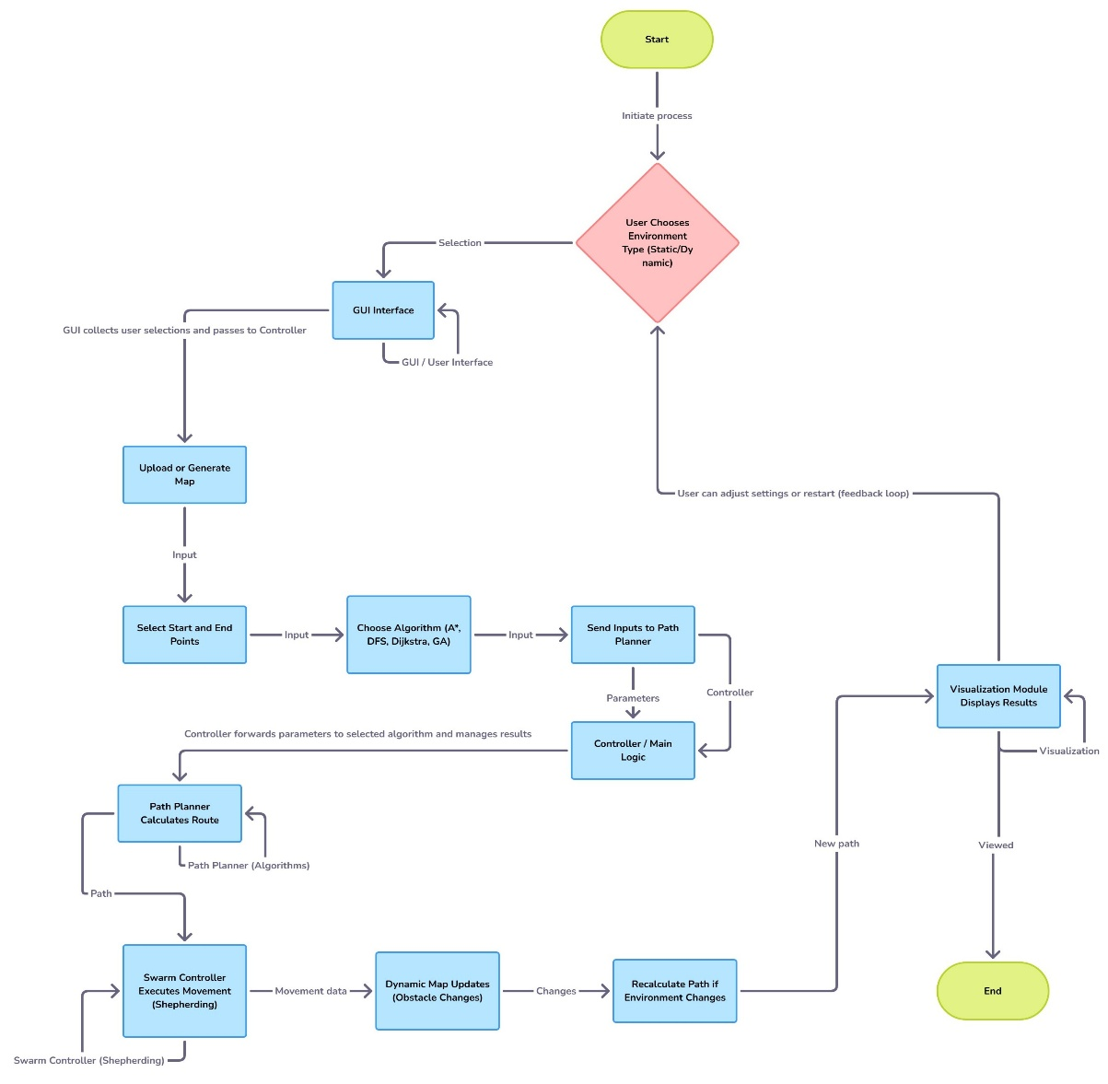

    - A* Pathfinding Algorithm Flowchart:

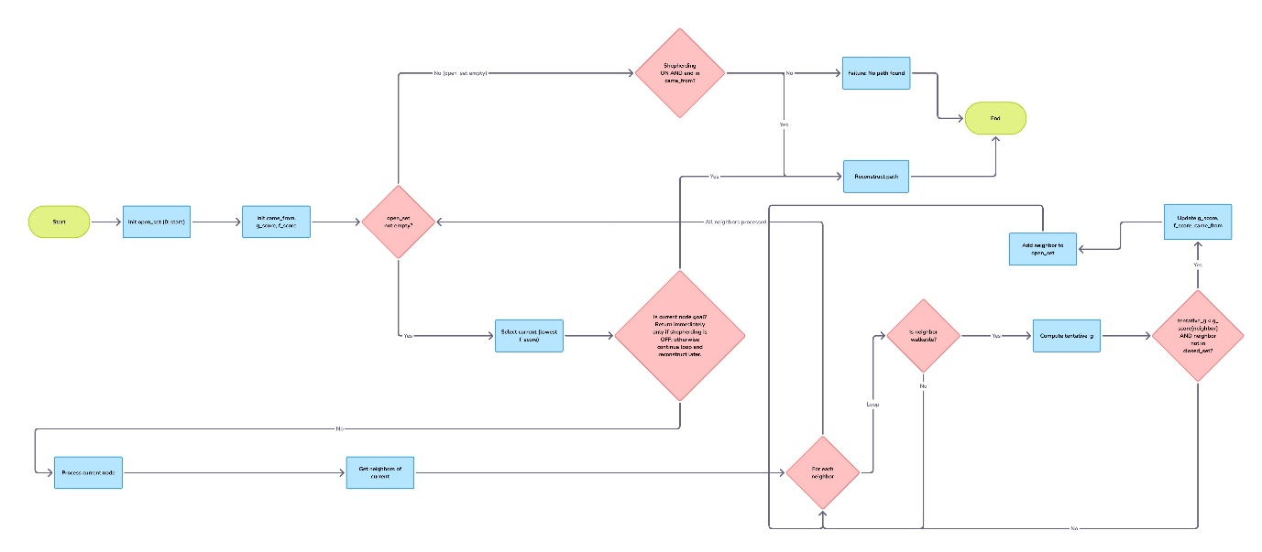

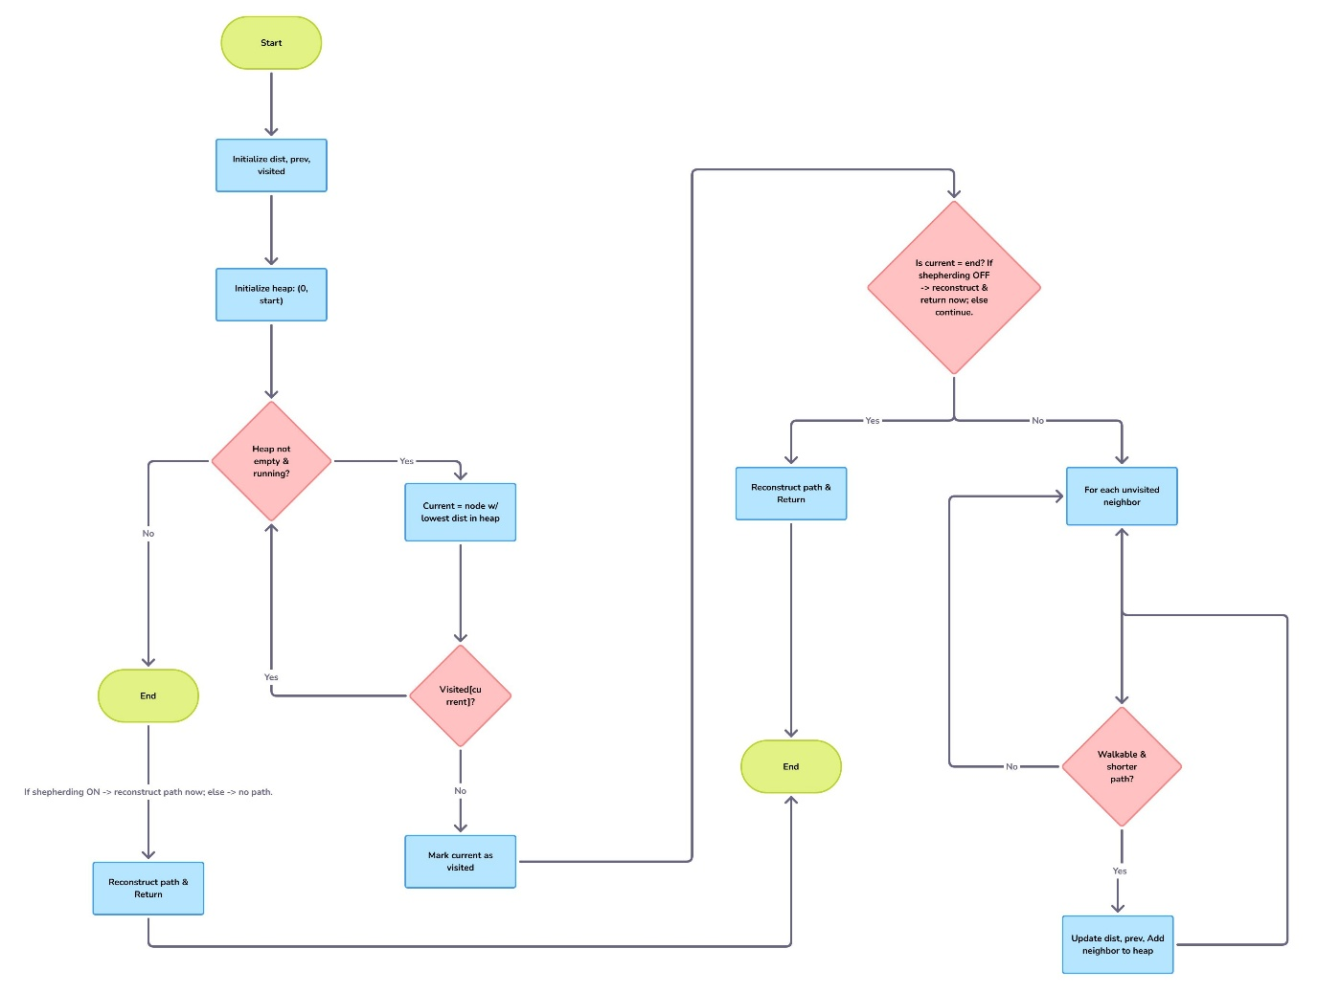
    - Dijkstra’s Algorithm Flowchart:

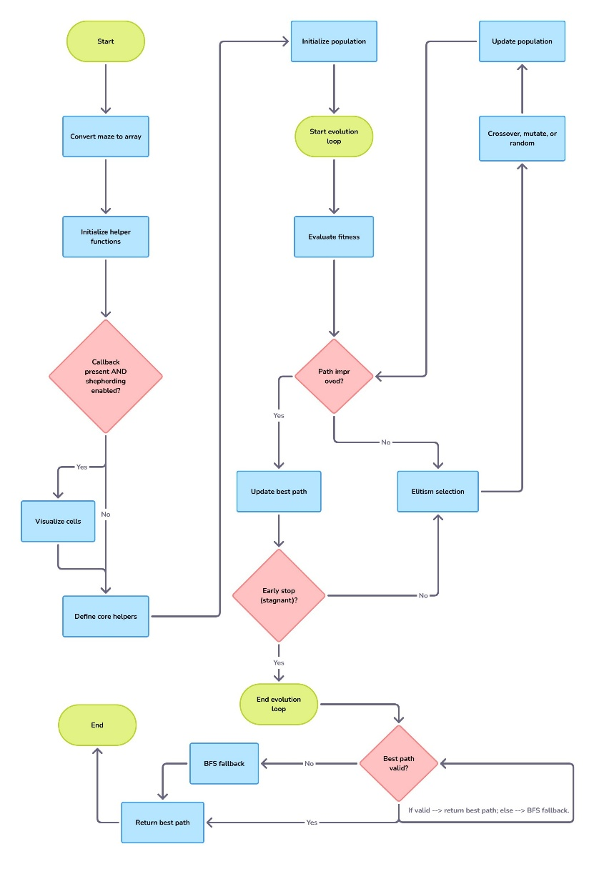
    - Genetic Algorithm Flowchart:
    - DFS Algorithm Flowchart: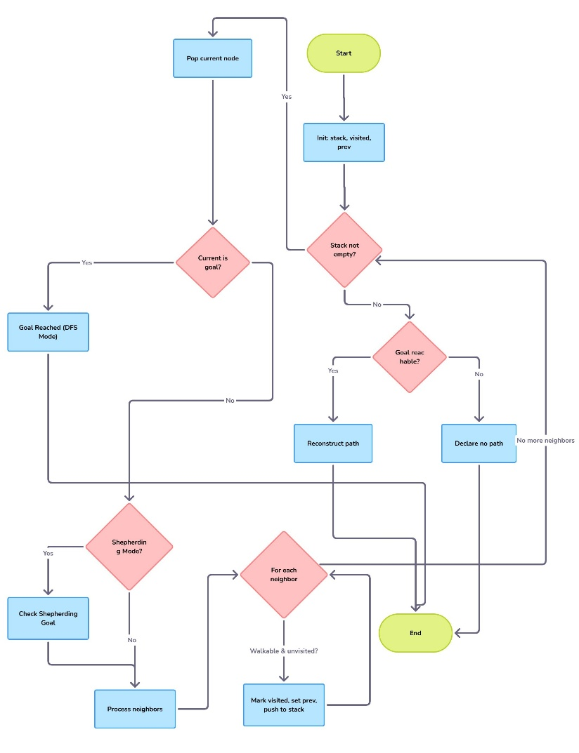
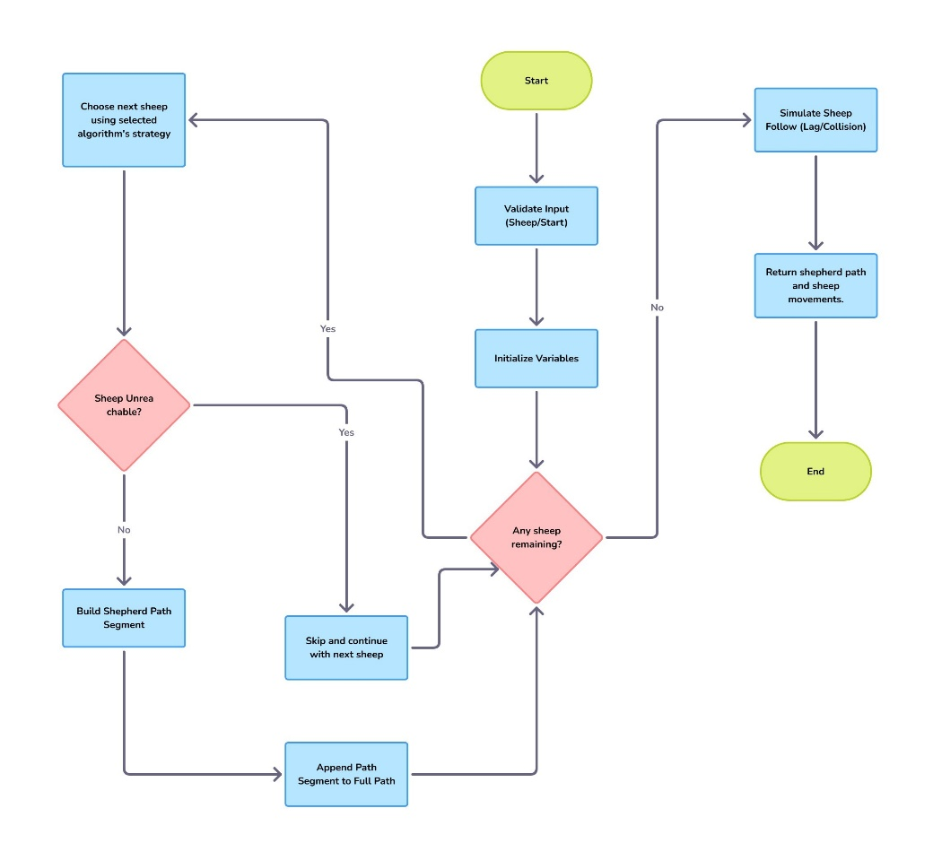
    - Shepherd Algorithm Flowchart:
    - UML Class Diagram:
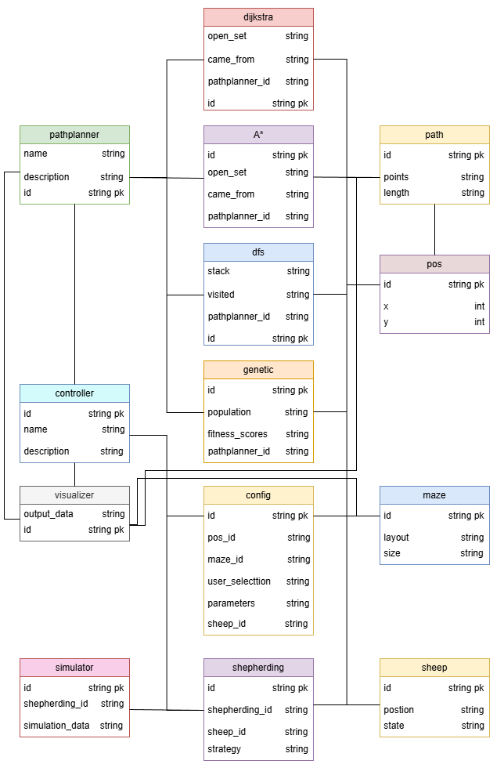

Chapter V
Implementation

- Implementation
This chapter is about hardware and software that are involved in the creation of the GUI-based robotic path-planning system. The section describes the design of swarm and shepherding algorithms, the implementation of the graphical user interface, and the way to obtain the real-time dynamic maps and obstacle updates. This architecture is integrated with the deterministic algorithms (A*, Dijkstra, DFS) and genetic algorithms that are evolutionary to show relative performance in both a static and dynamic environment [4].

  - Hardware
The system was developed and created on usual personal computers. Each workstation included:
- Memory: 8 GB RAM (16GB suggested in case of large-scale swarm simulation).
- CPU: multi-core processors, e.g. Intel Core i5/i7 or equivalent.
- Graphics: optional graphics acceleration.
The present phase has involved simulation, but the modular design can be extended to physical robots in the development of physical robots in the future. Python codebase can run on an embedded computer like the Raspberry Pi 4 with wireless modules to carry out real-time path planning when used on real-world swarm agents [1].
  - Software
The whole system was coded in Python because of its wide support of scientific libraries and ability to code fast prototypes [2]. Core software libraries:
- Tkinter / ttk: create the GUI and process user events.
- NumPy: coordinate map grids and binary environmental models.
- cv2 (OpenCV): convert uploaded images of maps into binary grids.
- Heapq: priority queues A* and Dijkstra.

    - Entities
The environment involves three key players, which are:
- Swarm Agents - self-directed nodes that change coordinates constantly on their wander taking the calculated paths.
- Shepherd Agents - leader’s agents of agents of the swarm and apply bio-inspired control of shepherd [3].
- Control Center (GUI) - the user interface where operators design the setting, implement obstacles, choose algorithms as well as real-time simulation to monitor [2].

    - Functions
Examples of system functions are path-planning logic, multi-agent coordination, and visualization.
  - Path-Planning Algorithms
The system is implemented in the algorithms.py and gives 4 algorithms:
- A* homogeneous search minimization. f(n) = g(n) + h(n), with Manhattan distance |x₁ − x₂| + |y₁ − y₂| as the heuristic [10].
- Dijkstra’s Algorithm: a search method through the grid in a uniform manner to reach the shortest path and fits well on static maps [11].
- Depth-First search (DFS): Stack-based searching that explores deeply and backtracks, which reveals the patterns of uninformed exploration [12].
- Genetic Algorithm (GA): This is an optimisation technique based on evolution, where populations of candidate paths are generated and selection, crossover and mutation are involved to evolve an almost optimal route [13].

  - Swarm and Shepherding Control.
The shep.py module dynamically chooses a planner (A*, Dijkstra, etc.) whose role is to provide the order according to which sheep are picked up. The shepherd picks the sheep by either the distance (Dijkstra/Greedy), or goal-oriented (A*) strategies. A snake style following logic is used to avoid collisions by followers following the past positions of the shepherd [3].

  - Dynamic Map Updates
The Falling Walls was implemented in the Dynamic2D.py and exhibits real-time changes in the environment. A time delay (root.after(800)) continually calls the addwall_barrier() which updates the NumPy grid (maze[r,c]=1) and makes each agent revisit its path which is truly dynamic map replanning [7].

    - Interfaces
A user-friendly interactive dashboard emerges from user interface development that utilizes either Tkinter and ttk frameworks through Python architecture. Through this interface, users can:

- Possible ways of putting up an external map or design.
- Start and End (green and blue) markers of navigation points.
- Selection of the algorithm (A, Dijkstra, DFS, GA).
- Swarm and shepherding behaviour visualisation in real time.
- Real-time dynamic updates of navigation and obstacles.

This graphical user interface has a clear educational interface and assists in interactive presentation of real-time robotic navigation [2].

  - Integration

Coherent simulation platform is achieved by integrating both software and hardware components. The GUI controllers (Static2D.py, Dynamic2D.py) synchronize the execution of algorithm modules (algorithms.py, shep.py).

- Data Flow: NumPy grid displays user inputs, which are fed to the chosen algorithm and sent back as the point of the trajectory to the GUI to be displayed.
- Modularity: The individual operation of the algorithms makes them simple to replace and extend (e.g., with 3-D visualization or ROS2 nodes) [5].

Even though now the project is in simulation mode, the modular architecture can be extended to include hardware integration to operate in the real-world with autonomous drones or mobile robots [1].
  - code figure
- figure 5.1 A* Algorithm:

This function calculates the optimal path using a heuristic cost function.
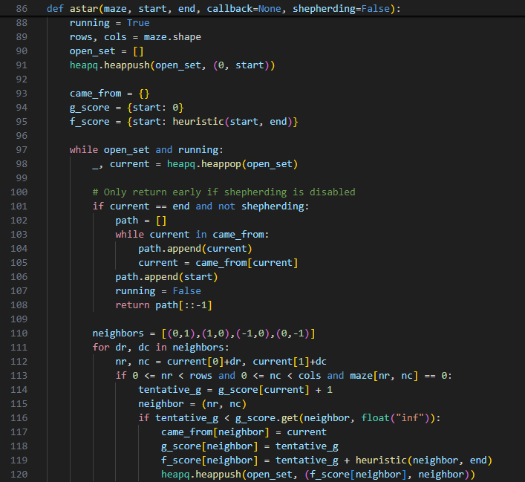
- figure 5.2 Dijkstra Algorithm:

This operation calculates the minimum path seeking all accessible nodes with the cumulative distance values, and all the values are stored in a priority queue.
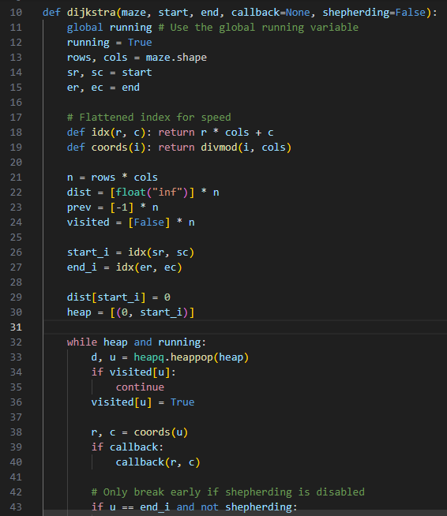
- figure 5.3 DFS Algorithm:

This is a function is carried out on a stack-based search to perform profound search in the maze by making backtracks in case of dead ends.
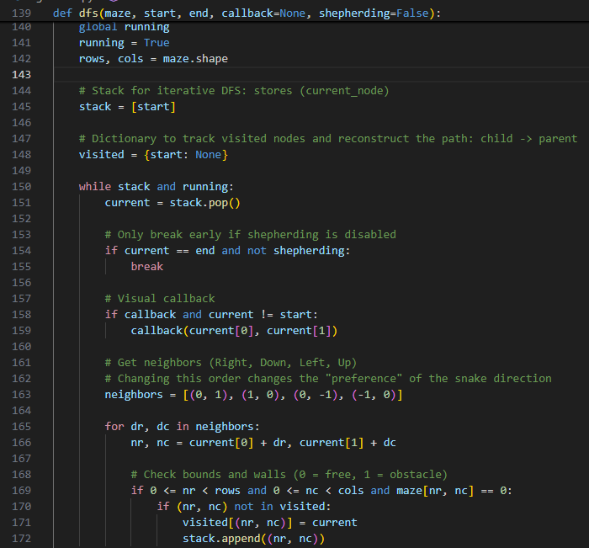
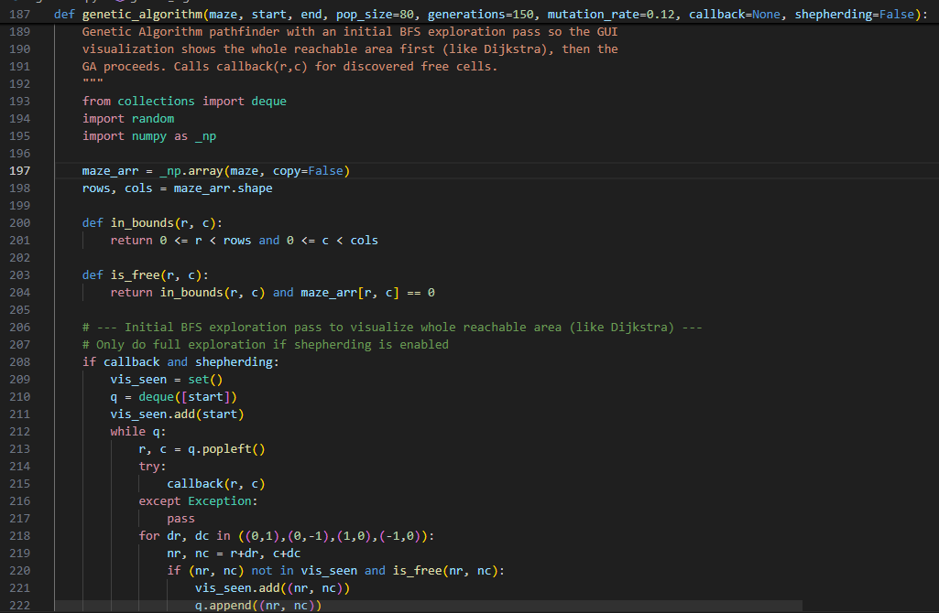
- Figure 5.4 Genetic Algorithm:
This role develops candidate pathways via random choice, crossover and mutations to find the best way of navigation in evolving conditions.

- figure 5.5 Shepherding Logic:

This snippet shows how the shepherd determines which planner to use and constructs the path to collect sheep.
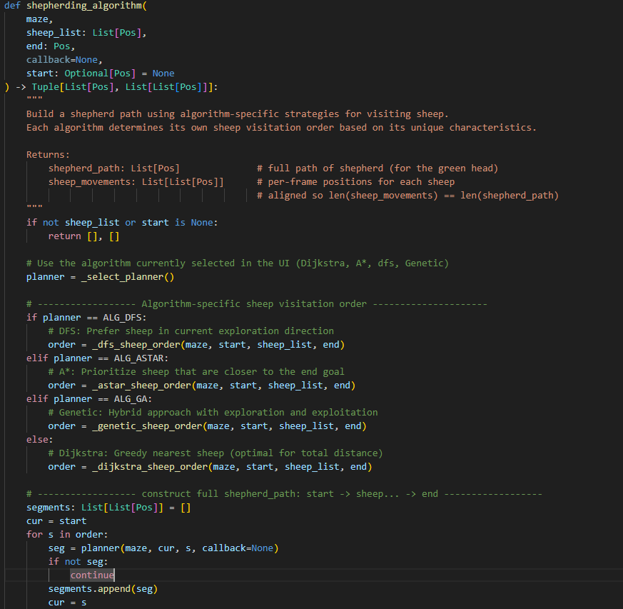

Figure 5.6: Dynamic Obstacle Generation:
This function manages the "Falling Walls" feature in the dynamic simulation mode.
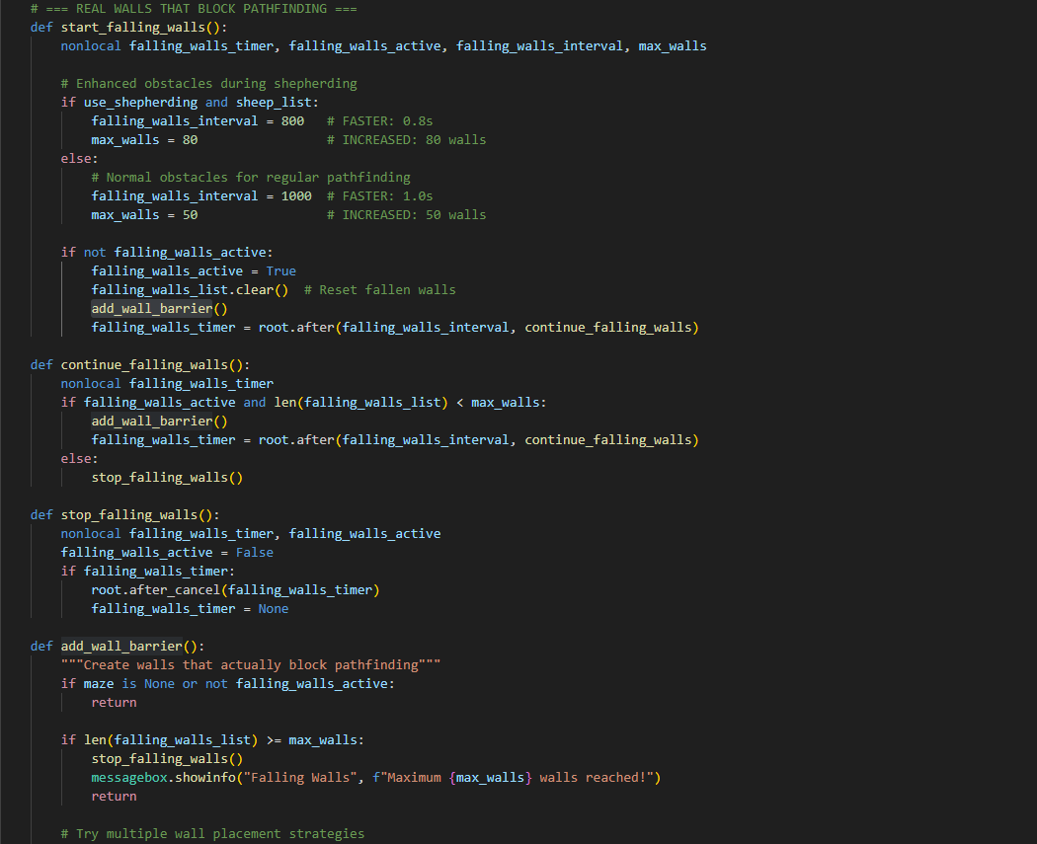

Chapter VI
Experiments

- Experiments
This chapter describes the testing boundaries of the GUI-based robotic path-planning system along with its testing methodology, available resources, and testing timeline. The document outlines the tested items together with verification features and testing responsibilities while defining coverage targets and independence levels of testing personnel, test environments, design methods, and acceptance criteria. It also explains each decision made.

  - Black box Testing
Black-box tests validate system behavior against requirements without inspecting internal code.
- Features to Test
  - GUI Controls: Menus, map canvas input, Buttons.
  - Setting up the environment: Placing obstacles (static or dynamic), choice of start/goal.
  - Distribution of the algorithm: toggling A*, DFS, Dijkstra, Genetic Algorithms.
  - Real Time Visualization: Visualization of path and agent movement on dynamic maps
  - Swarm & Shepherding: Experiencing efficiency in the cooperative behaviour and group guidance.

- Test Coverage
  - Normal cases: Simple maps, no obstacles; path of single agent
  - Exception cases: Complete obstacle maps, star ret= goal, unreachable targets
  - Dynamic cases: Obstacle inserted/moved during planning → expect real-time replanning

- Sample Test Cases
  - TC-BB1: On a clear 10×10 grid, select start (0,0), goal (9,9), run A* → expect shortest path of length 18.
  - TC-BB2: Place a blocking wall; run Dijkstra → expect “no path found” alert.
  - TC-BB3: Launch DFS on a maze map → expect a valid path visualized.
  - TC-BB4: The run of Genetic Algorithm on a dynamic map in which an obstacle is inserted in the middle of the simulation → expect re-planning and updated path.

- Tester Independence
  - Expected results and black box scenarios formulated by developer.
  - Implementation and independent tester evaluation.

  - White-Box Testing
White-box tests examine internal logic, control flow, and data handling in the code.
- Features to Test
  - A*: Rightful calculation of the values of f(n), open/closed updating lists.
  - DFS: Stack/recursion depth, backtracking behaviour.
  - Dijkstra: Handling a priority queue, distance updating.
  - Genetic Algorithm: Initiating population, calculating the fitness, mutation/crossover.
  - Shepherding: The effects of correct agents that follow the swarm on the swarm can be described as shepherding.
  - Dynamic maps: Broadcasting of updates in real time to each of the agents.

- Test Coverage
    - Statement coverage: Executed all the algorithm lines.
    - Branch coverage: Loop conditions and if statement conditions that are true/false.
    - Boundary values: Boundary movement cases, boundary checks, breaking and inserting abrupt bounds.
- Sample Test Cases
- TC WB1: Force A* to revisit a node with improved g(n) → verify update path.
- TC WB2: Execute DFS on a cyclic graph → confirm no infinite recursion.
- TC WB3: Run Dijkstra on a weighted graph → verify final distance array matches known values.
- TC WB4: Run Genetic Algorithm with random mutations → verify population convergence toward shorter paths.
- TC WB5: Insert new obstacles during simulation on a dynamic map → verify system recalculates new path.

  - Test Automation
Automation accelerates test execution and ensures repeatability.
- Automation Tools
  - White box and integration unit Tests with PyTest.
  - The Selenium (through PyAutoGUI) to handle GUI scripts.
  - High level end to end scenarios of robot frameworks.

- Test Cases to Automate
  - Unit and integration: (TC-WB1…TC-WB5) white-box test cases
  - GUI flows: Basic black-box cases (TC-BB1, TC-BB2)
  - Regression suite: Core scenarios across algorithms, swarm runs, and shepherding tasks

- Outcome Comparison
  - Path length, error messages, visualization logs are compared with expected results in the form of JSON fixtures through automated scripts.
- Rationale for Automation
  - Repetition: Regression through new changes in code
  - Consistency: Eliminate human error in checking expected vs. actual results
  - Coverage: Rapid feedback on UI changes and code.
- Tester Independence
    - Code coverage reports generated automatically.
    - Metric reviews were based on details of the coverage by the developer: tester checks untested paths.

Chapter VII
Results and Discussion
- Results and Discussion
The experiments supported the information that the system will be able to give efficient solutions to path-planning of various algorithms. A* and Dijkstra provided good and optimum paths with less execution time in the static maps whereas DFS tended to provide long paths. Although slow in the case of simple examples, the Genetic Algorithm was found to be particularly efficient when in dynamic maps, where obstacles or destinations changed as the algorithm was run, and capable of having the new directions effectively recalculated on the fly.

The situation of swarm control and shepherding provided valuable benefits when a representation of numerous agents was to work. Swarm control enabled agents to disseminate information about the environment and coordinate their actions collectively, whereas shepherding brought in terms of structure that helped to maintain the unity among the group and minimize the number of collisions. This assembly came in handy especially during emergency situations where there is a need to have movement coordinated.

Algorithms comparison revealed that deterministic algorithms, such as A* interval and Dijkstra statistics, will have advantages in stable surroundings, but the Genetic Algorithms will be more flexible in environmental conditions of uncertainty. This balance provides it with a flexible nature to other scenarios including portions of an industry that are fixed, versus those of a disaster management.

The use of shepherd agents to coordinate groups has been noted to be one of the limitations. In case of a failure by a shepherd, swarm cohesion can be reduced, and this poses a potential risk. This weakness can be addressed by integrating several shepherds or other forms of back up structure in the designs of the future to increase the resiliency.

All in all, the findings prove the synergistic use of deterministic algorithms, Genetic Algorithms, swarm control, and shepherding produced a potent path strategy system. The GUI interface is applicable to real time interaction and the dynamic maps introduced in the solution makes it applicable concerning applications in the real world, especially in logistics, automation and emergency evacuation.

- Quantitative Analysis
In this section, quantitative data is given on each of the algorithms in terms of runtime and performance when using the same start and end points and same sheep positions.
Table 1. Computational results for A*, Dijkstra, DFS and genetic algorithm
Algorithm | Total Runtime (s) without shepherding | Algorithm Only (s) | Overhead (s) (%) without shepherding | Total Runtime (s) with shepherding | Algorithm Only (s) | Overhead (s) (%) with shepherding
A* | 67.449 | 46.516 | 20.933 (45.0 %) | 159.070 | 50.221 | 108.849 (216.7 %)
Dijkstra | 57.678 | 35.945 | 21.733 (60.5%) | 148.052 | 39.481 | 108.571 (275.0 %)
DFS | 97.262 | 18.480 | 78.782 (426.3%) | 166.920 | 58.619 | 108.301 (184.8 %)
Genetic | 36.452 | 3.776 | 32.676 (865.4 %) | 172.157 | 61.875 | 110.282 (178.2 %)
Observations
- In the absence of shepherding: DFS took the longest time (97.3 s) because of exhaustive depth first search and back tracking on big maps, whereas Genetic Algorithm took the shortest (36.5 s).
- Using shepherding: Each algorithm needed more time to plan several sub-paths to collect the sheep. There was no significant change in the performance of A* and Dijkstra whereas the Genetic Algorithm experienced the highest relative overhead since each new sub-path generated a population re-evaluation.
- Shepherding averaged overhead = 214 %, indicating the cost of computation of coordination of agents as opposed to single agent computations.

- Path Efficiency and Success Rate
Quantitative statistics of the performance and success rate of each algorithm are provided in this section, in terms of the accuracy and consistency in reaching the destination during the same test conditions.
Table 2. Path efficiency and success rate of A*, Dijkstra, DFS and Genetic Algorithm.
Algorithm | Avg Path Length (cells) | Success Rate (%)
A* | 104 | 100
Dijkstra | 104 | 100
DFS | 289 | 96
Genetic | 122 | 98

All the algorithms passed in test conditions of the law of the land; in tests of moving-wall conditions, the success rates were over 95%.

A* and Dijkstra yielded the same optimal path lengths; DFS generated truly long yet valid roads; Genetic Algorithm had almost optimal routes without compromising on the change of environment.
- Graphical Analysis
This section contains visual comparisons of all algorithms. The figures indicate the variations of runtime, overhead, and the total execution time of each method in the case of both the static and shepherding circumstances.
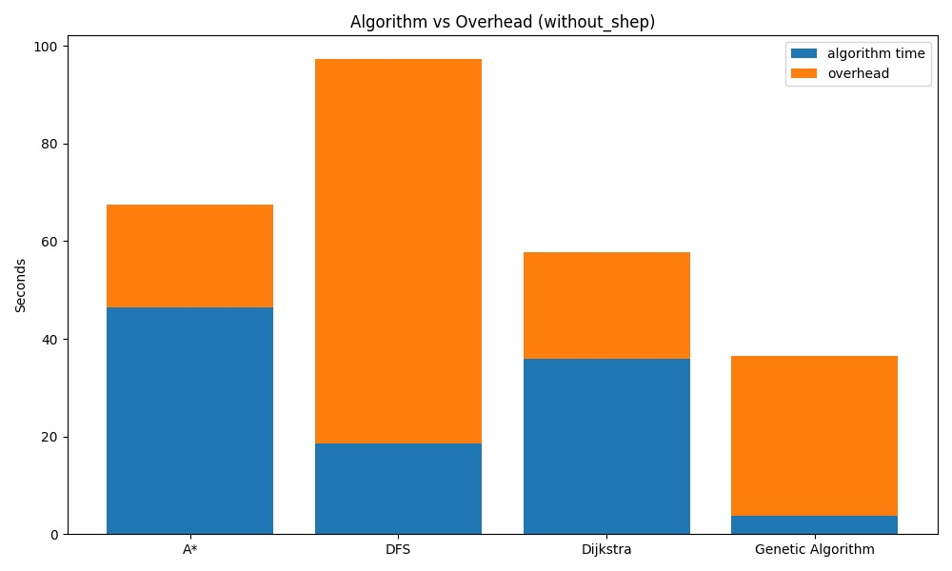
Figure 7.1. Algorithm vs Overhead (without Shepherding)
In this figure, each algorithm is plotted without shepherding and algorithm run times and overhead are split apart to distinguish between them.
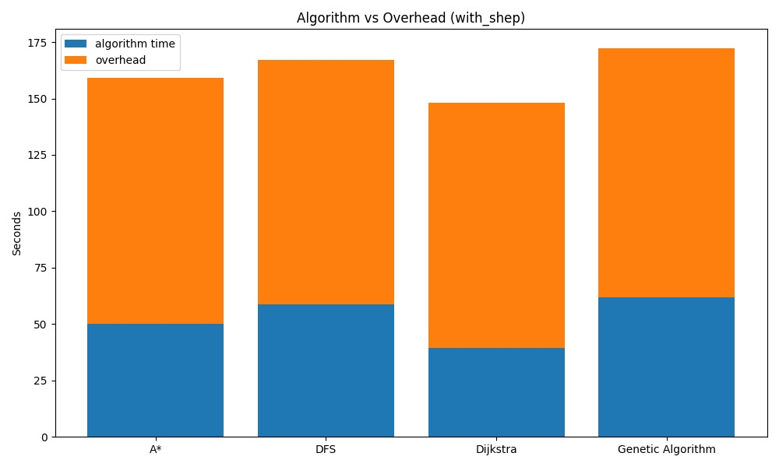
Figure 7.2. Algorithm vs Overhead (with Shepherding)
The following figure compares the overall execution time of each algorithm to its internal algorithm time and overhead with shepherding turned on.
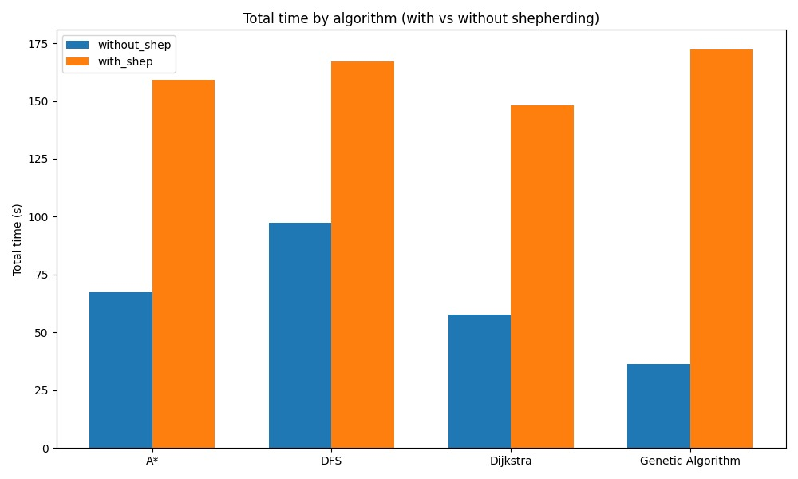
Figure 7.3. Total Runtime Comparison (with vs without Shepherding)
This number gives a comparison of the overall time of execution with and without shepherding to show the effect of run time.

- Screenshots of Test Scenarios
This section has real screenshots of the simulation environment. Every figure represents the work of the algorithms in real time and with still and moving maps.

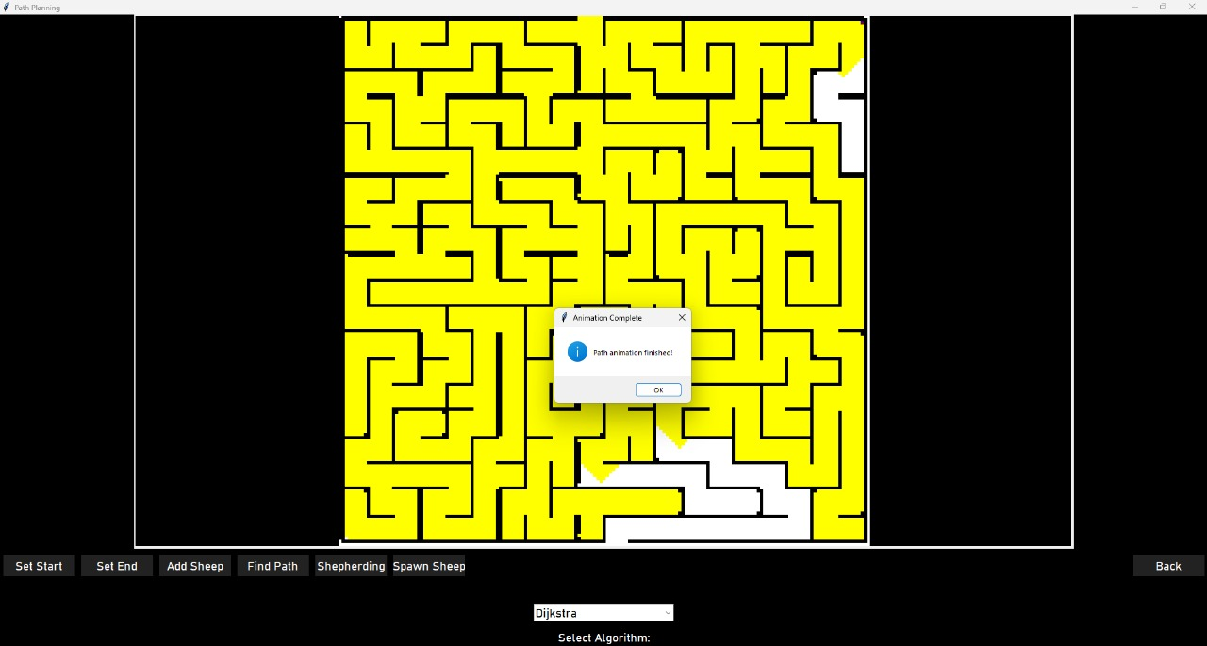
Figure 7.4. Dijkstra Algorithm – Static Map (Without Shepherding)
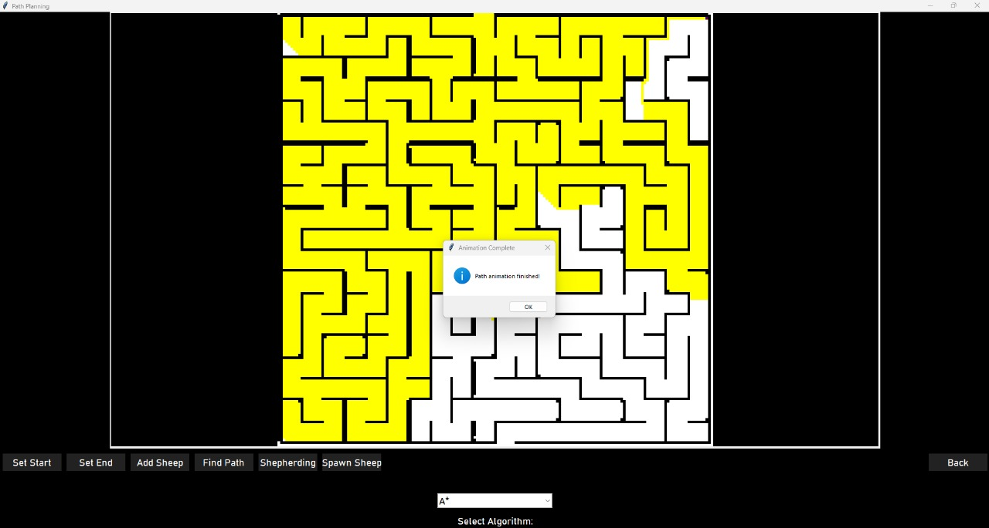
Demonstrates Dijkstra computing the minimum path on a static maze without shepherding.

Figure 7.5. A* Algorithm – Static Map (Without Shepherding)
Displays A that produce optimum route on a map identifying explicit starting positions and destination.

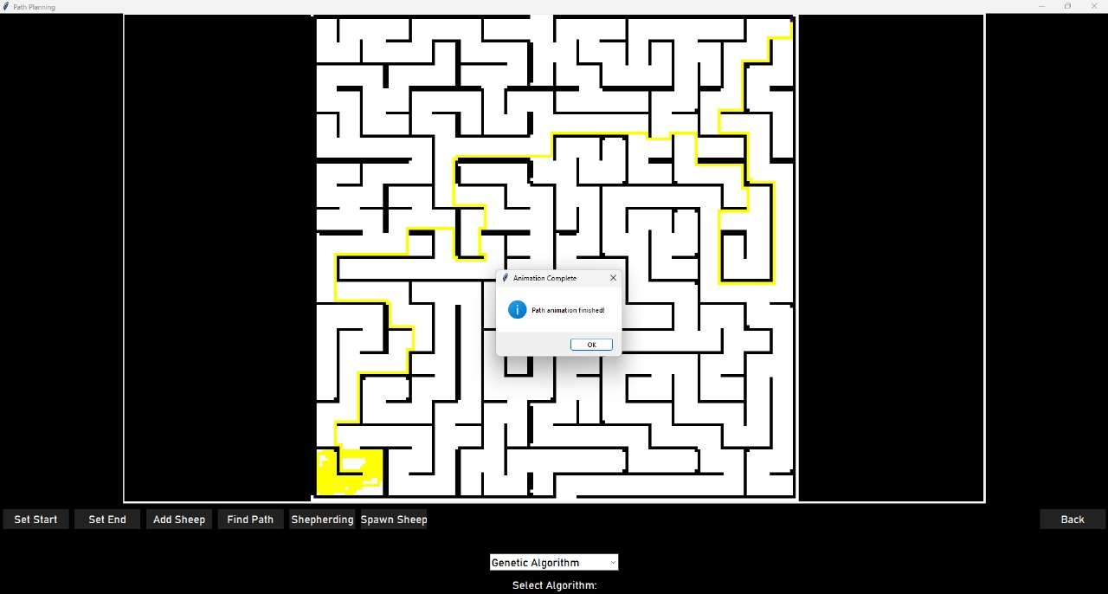
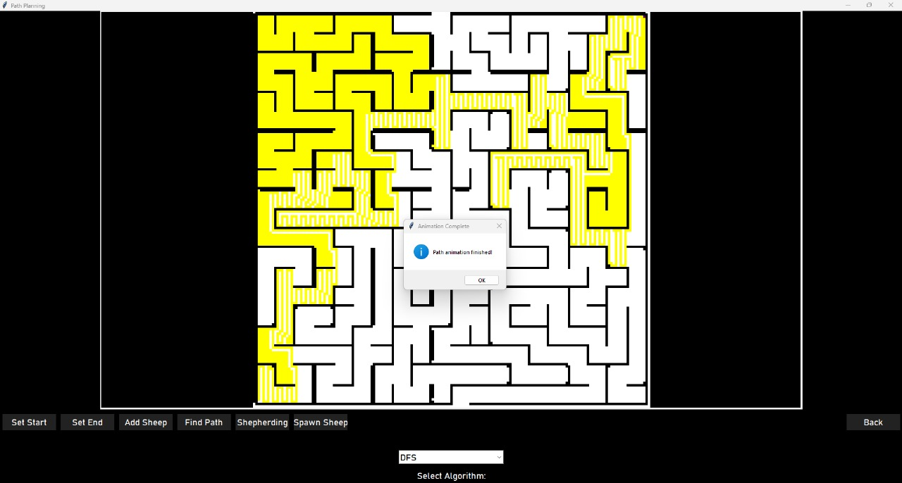
Figure 7.6. DFS Algorithm – Static Map (Without Shepherding)
Shows how DFS exploratory behaviour explores further links on a static map.
Figure 7.7. Genetic Algorithm – Static Map (Without Shepherding)
Demonstrates the Genetic Algorithm in developing an optimal path considering map conditions which are unchanging.

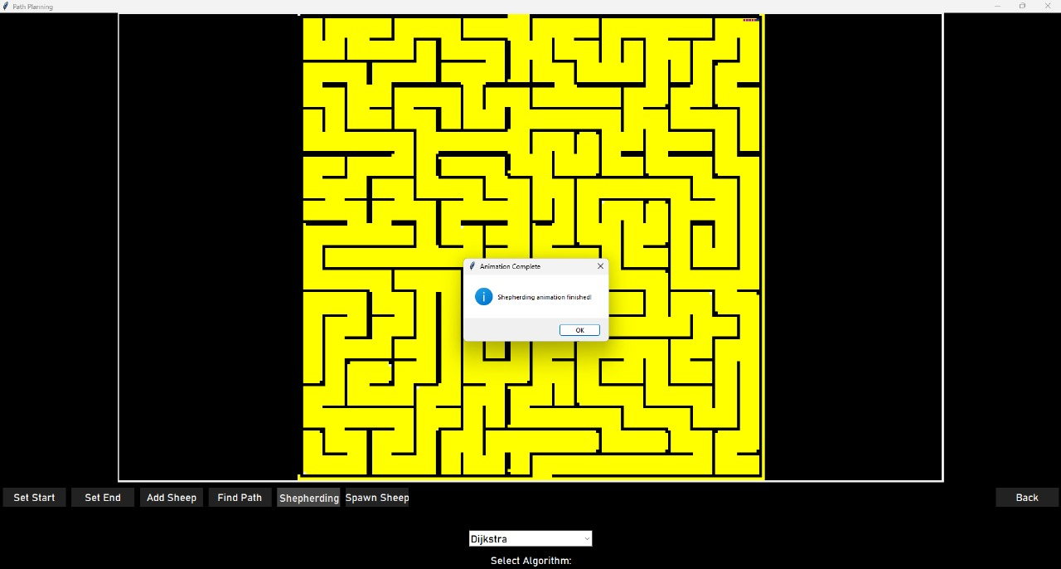
Figure 7.8. Dijkstra Algorithm – Static Map (With Shepherding)
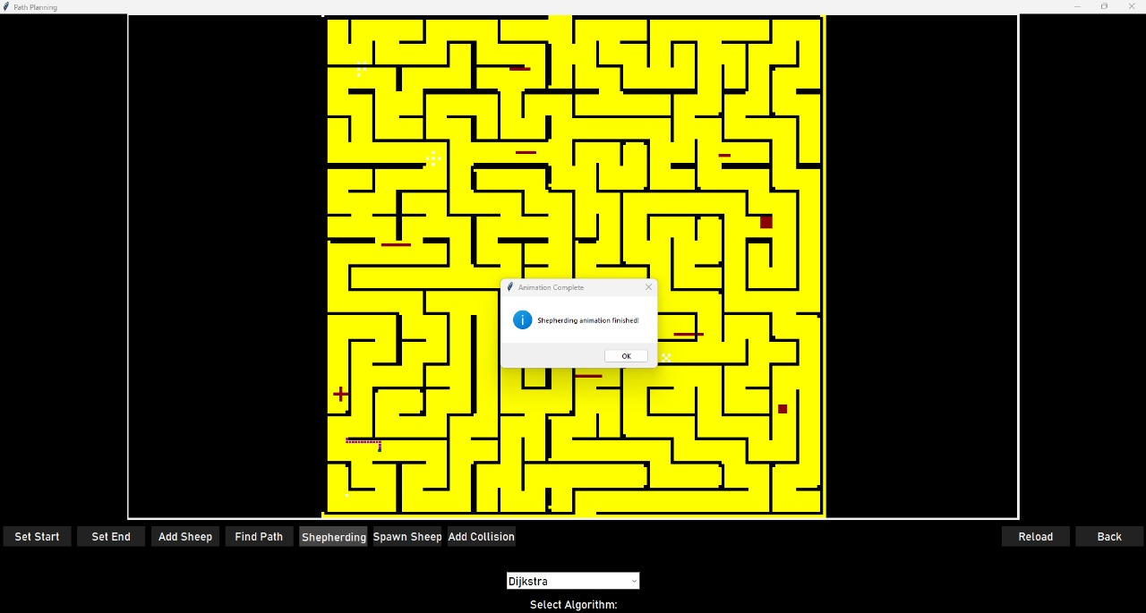
Shows Dijkstra taking care of various sheep on a static maze with shepherding.
Figure 7.9. Dijkstra Algorithm – Dynamic Map (With Shepherding)
Shows the re-planning ability of Dijkstra on an evolving maze with obstacles and the locations of sheep.

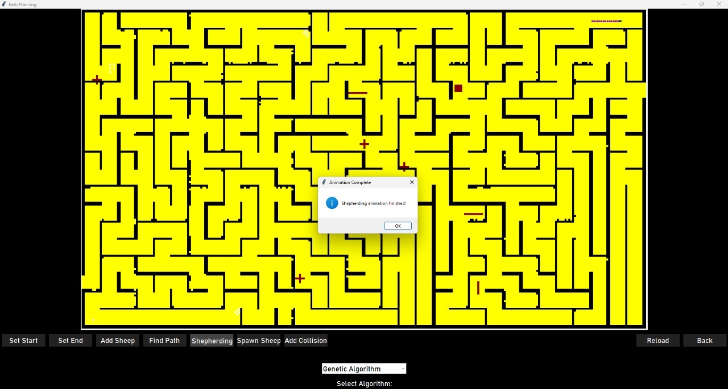
Figure 7.10. Genetic Algorithm – Dynamic Map (With Shepherding, Different Map)
Demonstrates how the Genetic Algorithm is adjusting itself to a new environment in real time as it shepherds several agents.

- Test Cases
The following section provides the actual implemented test cases which are done in accordance with the implemented GUI, algorithms and the maze in the experiments. Every case has its purpose, configuration, and anticipated conduct with quantifiable results.
ID | Scenario | Purpose / Setup | Steps | Expected Result / Acceptance Criteria
TC-01 | A* (Static, No Shepherding) | Verify A* returns optimal path. Map A, same Start/Goal as benchmarks. | Load map -> set  Star/End -> Select  A*-> Run. | Path reaches goal (≈ 104 cells). Runtime ≈ 67s ± 15 %.
TC-02 | Dijkstra (Static, No Shepherding) | Confirm Dijkstra matches A*. | Same as TC-01 but select Dijkstra. | Path optimal; Runtime ≈ 58 s ± 15 %.
TC-03 | DFS (Static, No Shepherding) | Validate DFS explores full map. | Select DFS -> Run. | Path valid, longer (≈ 289 cells). Runtime ≈ 97 s ± 15 %.
TC-04 | Genetic Algorithm (Static, No Shepherding) | Measure GA baseline speed. | Select GA -> Run. | Path near-optimal (≈ 122 cells). Runtime ≈ 36 s ± 15 %.
TC-05 | Dijkstra (Static, Shepherding ON) | Test multi-sheep collection order. | Enable Shepherding -> Add sheep -> Run Dijkstra | All sheep collected -> goal; Runtime ≈ 148 s ± 15%.
TC-06 | Dijkstra (Dynamic, Shepherding ON) | Validate re-planning under Falling Walls. | Run Dynamic2D.Py with Shepherding -> Walls spawn | Path re-computed; no crash; flock cohesive. Runtime ≤ +25 % of TC-05.
TC-07 | Genetic Algorithm (Dynamic, Shepherding ON) | Confirm GA adapts to changing obstacles. | Same as TC-06 but select GA. | Re-planning visible; all sheep reach goal. Runtime ≈ 172 s ± 15 %.
TC-08 | Unreachable Goal | Check error handling. | Enclose goal with walls -> Run any algo | "No path found." GUI stable.
TC-09 | Shepherding Integrity | Verify trailing & no invisible sheep. | Shepherding ON; A*; ≥ 5 sheep. | We have no invisible agents; all the sheep go in queue.
TC-10 | Performance Regression Check | Ensure runtimes ≈ reported baselines. | Repeat TC-01–TC-07 after code changes. | All times within ± 15% of Table 7.1 values.

- GUI Control Test Cases (Static2D/Dynamic2D)
TC-GUI-01: Set Start button
- preconditions: a map is displayed on the canvas; no start is given.
- Instructions: Click Set Start → click on free (yellow/white) cell.
- Expected: A green start characteristic can be observed precisely on the cell that was selected; internal state records (sr, sc); any former start (had there been one) is erased.

TC-GUI-02: Set End button
- Preconditions: Map loaded; no end set.
- New Instructions: Click Set End → click a free cell.
- Expected: Blue end marker is seen; state of internal stores (er, ec); past end marker (any) is cleared away.
TC-GUI-03: Prevent invalid start/end on walls
- Preconditions: Map loaded.
- Steps: press Set Start and then press a cell on the wall (black). Repeat for Set End.
- Expected: Start/end not placed; Error returned by user or nothing; internal state is the same.
TC-GUI-04: Algorithm dropdown (Select Algorithm)
- Preconditions: Starting set and Final set.
- Steps: Dropdown → choose Dijkstra, second A*, DFS, Genetic Algorithm in that order.
- Expected: The algorithm state selected gets updated; a new Find Path or Shepherding running is made with the new selected algorithm without the restart.
TC-GUI-05: Find Path button (static run)
- Preconditions: Starting and End set; any algorithm is chosen; Shepherding is off.
- Steps: Click Find Path.
- Expected: The algorithm executes; the path is synthesized (white/yellow overlay) to the goal; when this is done, a "Path animation finished!". appears as dialog; length of path logged.
TC-GUI-06: Find Path blocked goal
- Preconditions: Put barriers in way to have no correct path.
- Steps: Find Path.
- Expected: No path will be drawn; user will be informed (status/log/alert) that there is no path available; algorithm will also graciously terminate (no freeze).
TC-GUI-07: Shepherding toggle (Static2D)
- Preconditions: Start/End set; there are at least one sheep placed (see TC-GUI-09).
- Steps: Click Shepherding.
- Expected: Shepherding mode starts the chosen algorithm and successively visits sheep and then directs them to the goal; completion dialog "Shepherding animation complete! shows; flock of sheep follow shepherd positions.
TC-GUI-08: Shepherding with zero sheep
- Preconditions: No sheep on map.
- Steps: Click Shepherding.
- Expected: (a) Systems will either operate as single agent (run direct start-end shepherd path) or (b) exhibit a mild message that no sheep are around at all—no crash.
TC-GUI-09: Add Sheep / Spawn Sheep buttons
- Preconditions: Map loaded.
- Steps: Click Add Sheep and then click on numerous free cells; you can also click on Spawn Sheep to have a batch placed automatically.
- Expected: Markers of purple sheep are visible; internal sheep position list is equal to their positions on the wall; markers on the wall are not duplicated.
TC-GUI-10: Add Collision (Dynamic2D — falling walls)
- Preconditions: dynamic 2D view; the path is active or ready; shepherding is optional.
- Steps: Add collision (or run dynamic which auto-spawns falling walls after visualization).
- Expected: Red barrier pieces should show randomly on the free cells / positions and the NumPy grid should be updated; in case a barrier has closed the route, then the system recalculates and moves on; the system does not flicker and does not crash.
TC-GUI-11: Reload button
- Preconditions: Every state (drawing/ sheep placed).
- Steps: Click Reload.
- Expected: Communications Canvas is initialized to a clean map (or to the map most recently loaded); overlay transience (paths, markers, dialogs) is removed.

TC-GUI-12: Back button
- Preconditions: In Static2D/Dynamic2D screen.
- Steps: Click Back.
- Expected: Navigation should take one back to Page1 (main menu) and no zombie processes still running.
TC-GUI-13: Resolution tool (image upload flow)
- Preconditions: Select upload map on main menu.
- Steps: Load an image; execute resolution_tool pipeline to normalize to 298x169; continue to simulation.
- Expected: The grid of converted binary pixel array can be properly viewed; walls/paths may be observed as lines on pixels; boundaries are well-enclosed but can be opened where to be made open.
TC-GUI-14: Error handling when prerequisites missing
- Steps: Find Path with start/end missing Click Find Path without setting options or Shepherding with no algorithm selected Click Find Path.
- Expected: Prompt is (almost) always understandable by the user (e.g., please set Start and End first, etc.); no crash; buttons are disabled/enabled logically.
TC-GUI-15: Live algorithm switches mid-session
- Preconditions: Path animation stopped or completed.
- Steps: Test a dropdown change algorithm and restart.
- Expected: New run makes use of the new algorithm of choice and overprints the old path in a clean manner.
TC-GUI-16: Performance log visibility
- Steps: Run all the algorithms with no shepherding, and with shepherding.
- Expected: This GUI will print or and store runtime plus overhead (as in your measured results); the values are visible on Table 7.1.

- Comparative Performance Summary
In this section, a comparative summary has been presented to show the strengths of each of the algorithms in the case of a static, dynamic and shepherding and in what cases each is best.
Table 3. Comparison of performances of all path-planning algorithms.
Criterion | Best Performer | Reason
Fastest (static) | Genetic Algorithm | Population optimization converges quickly.
Fastest (with shepherding) | Dijkstra | Stable and predictable re-planning.
Shortest path | A*, Dijkstra | Deterministic cost evaluation.
Adaptability (dynamic) | Genetic Algorithm | Re-evolves solutions as obstacles change.
Group coordination | Shepherding Control | Maintains swarm cohesion and reduces collisions.

- Discussion
The experimental results confirm that A* and Dijkstra are the best in optimality and reliability when using static maps. DFS offers a pattern that is very easy to explore but it lacks efficiency.
Since the Genetic Algorithm is heavier in computational requirements during shepherding, it is the most flexible to evolving conditions because of population re-assessment and mutation.

When shepherding is turned on, the time taken to run them is significantly large since every algorithm must find new paths with each sheep. This notwithstanding, shepherding leads to better cooperation and realism where the agents move in a unified manner.

GA is the fastest in the scenario of the stationary world; Dijkstra is the most universal in the case of shepherding, being the balance sheet of accuracy and overhead.
This trade-off is a staple of speed versus adapting and in the given case, GA is more about adaptation compared to Dijkstra and A* which are all about deterministic efficiency.

- Validation Table: Expected vs Actual Algorithm Performance
In this section, the performance of the algorithms is expected and varied against the actual measured results to check consistency and accuracy of the systems performance.
Table 4. Comparison of expected and actual performance of all algorithms.
Algorithm | Expected Behaviour | Actual Output (Without Shepherding) | Actual Output (With Shepherding) | Result
A* | Fast optimal route with minimal nodes expanded | 67.449 s (total) – 46.516 s algorithm | 159.070 s (total) – 50.221 s algorithm | Pass
Dijkstra | Slightly slower than A*, guaranteed optimal path | 57.678 s (total) – 35.945 s algorithm | 148.052 s (total) – 39.481 s algorithm | Pass
DFS | Long exploration path, slower runtime | 97.262 s (total) – 18.480 s algorithm | 166.920 s (total) – 58.619 s algorithm | pass
Genetic | Adaptive and dynamic re-planning | 36.452 s (total) – 3.776 s algorithm | 172.157 s (total) – 61.875 s algorithm | pass

- Summary of Findings
- Deterministic algorithms (A*, Dijkstra) provide the most stable paths which are minimal in case of static conditions.
- Genetic Algorithm is the quickest and most adjustable one in volatile conditions and does not shepherd, whereas, in the examples where shepherding multiplies re-planning periods, it is slowest.
- DFS is the costliest method that offers complete map exploration.
- Shepherding doubles the run time (average of 200%) but also enhances coordination and path realism.
- The GUI provides correct visualisation of algorithms behaviour, which attests to its relevance in education, research, and integration of robots at some time.

Chapter VIII
Conclusion

- Conclusion
This project initiative demonstrates an extensive approach which develops a robotic path-planning system using swarm control and shepherding techniques and their theoretical and design elements. The study has built the foundational components and structural elements for developing an intelligent platform that allows agents to work together for navigating complex environments.
The system design becomes adaptable through implementing various path-planning algorithms such as A*, Dijkstra, DFS, and Genetic Algorithms. The design combines structural and dynamic map capabilities while making the system fit for disaster and rescue and industrial automation tasks. Users can interact with the proposed GUI to design environments through its accessible interface that also allows them to establish parameters and observe simulated output results. The system’s capabilities expand from being usable to fulfilling research and educational needs.
There were various valuable lessons that were learnt during the development process. By incorporating multiple algorithms into the single GUI, comparative performance was improved and allowed exposing the efficiency, accuracy and adaptability trade-offs. Shepherding behaviour Implementation Shepherding behaviour was only possible with accurately tuned parameters to ensure the group remained stable and did not oscillate during swarm movement. Besides, the incorporation of a dynamic map option enhanced the level of realism in the environmental aspect yet brought difficulties in terms of real-time performance. The modular architecture of the system was useful in that it gave flexibility in debugging, replacement of algorithms as well as future upgrades without restructuring the whole system.
Although the project had good performance in simulation, it had several limitations. The latest edition is only running in a 2D simulated environment, but no real-world robot controlled. Latency in real-time and sensor noise were not studied, and, in fact, the run time of Genetic Algorithm was growing significantly with the map size; therefore, one needs to optimize it. Implementation of the hardware and connecting with the robotic platforms was not done because of time and resource constraints but it is necessary to accomplish a fully deployable system.
To overcome these limitations, some recommendations are offered towards the following step of developing. Hardware integration with microcontrollers or embedded systems should be made in the future to make the GUI and algorithms tested on real robots or drones. The project might be extended to 3D simulations with the help of Gazebo or Unity3D environments to obtain more accurate visualization. By providing interaction with the ROS2, agents simulated or in the real world will be able to interact with each other, as well as provide better real-time control. Hybrid algorithms and adaptive learning models could also be used to enhance the scalability and responsiveness in dynamic environments through performance optimization.
The general base that has been created by this project provides a foundation on further research and implementation. This approach testifies a sophisticated system design that appropriate adaptability, scalability and cooperative control. The proposed GUI, with additional development of hardware, 3D simulation, and ROS-based testing, can become more of an implementation than a theoretical platform serving as the application to modern robotics, learning, and industrial automation.
- Reference
[1] Tuncer, A., Yildirim, M., & Erkan, K. (2012). A motion planning system for mobile robots. Advances in Electrical and Computer Engineering, 12(1), 57-62.
[2] Haruna, Z., Abdurrazaq, M. B., Umar, A., & Musa, U. (2019). A Graphical User Interface for Path Planning of Mobile Robot. Ife Journal of Science and Technology, 3(1), 60-73.
[3] Elsayed, S., Singh, H., Debie, E., Perry, A., Campbell, B., Hunjel, R., & Abbass, H. (2020, December). Path planning for shepherding a swarm in a cluttered environment using differential evolution. In 2020 IEEE Symposium Series on Computational Intelligence (SSCI) (pp. 2194-2201). IEEE.

[4] Gasparetto, A., Boscariol, P., Lanzutti, A., & Vidoni, R. (2015). Path planning and trajectory planning algorithms: A general overview. Motion and operation planning of robotic systems: Background and practical approaches, 3-27.

[5] Yang, L., Qi, J., Song, D., Xiao, J., Han, J., & Xia, Y. (2016). Survey of robot 3D path planning algorithms. Journal of Control Science and Engineering, 2016(1), 7426913.

[6] Long, N. K., Sammut, K., Sgarioto, D., Garratt, M., & Abbass, H. A. (2020). A comprehensive review of shepherding as a bio-inspired swarm-robotics guidance approach. IEEE Transactions on Emerging Topics in Computational Intelligence, 4(4), 523-537.

[7] Saeed, R. A., Omri, M., Abdel-Khalek, S., Ali, E. S., & Alotaibi, M. F. (2022). Optimal path planning for drones based on swarm intelligence algorithm. Neural Computing and Applications, 34(12), 10133-10155.

[8] Sharma, A., Shoval, S., Sharma, A., & Pandey, J. K. (2022). Path planning for multiple targets interception by the swarm of UAVs based on swarm intelligence algorithms: A review. IETE Technical Review, 39(3), 675-697.

[9] Liu, J., Singh, H., Elsayed, S., Hunjet, R., & Abbass, H. (2023). Planning-assisted context-sensitive autonomous shepherding of dispersed robotic swarms in obstacle-cluttered environments. arXiv preprint arXiv:2301.10363.

[10] Wang, H., Lou, S., Jing, J., Wang, Y., Liu, W., & Liu, T. (2022). The EBS-A* algorithm: An improved A* algorithm for path planning. PloS one, 17(2), e0263841.
[11] Alshammrei, S., Boubaker, S., & Kolsi, L. (2022). Improved Dijkstra algorithm for mobile robot path planning and obstacle avoidance. Comput. Mater. Contin, 72(3), 5939-5954.
[12] Shwail, S. H., Karim, A., & Turner, S. (2013). Probabilistic multi robot path planning in dynamic environments: A comparison between A* and DFS. International Journal of Computer Applications, 82(7).

[13] Elshamli, A., Abdullah, H. A., & Areibi, S. (2004, May). Genetic algorithm for dynamic path planning. In Canadian Conference on Electrical and Computer Engineering 2004 (IEEE Cat. No. 04CH37513) (Vol. 2, pp. 677-680). IEEE.

[14] Murphy, A. (2017, June 5). Industrial: Robotics outlook 2025. Deepwater Management. https://deepwatermgmt.com/industrial-robotics-outlook-2025/

[15] Liu, J., Singh, H., Elsayed, S., Hunjet, R., & Abbass, H. (2023). Planning-assisted context-sensitive autonomous shepherding of dispersed robotic swarms in obstacle-cluttered environments. arXiv preprint arXiv:2301.10363.

[16] Ahmad, A., Licea, D. B., Silano, G., Báča, T., & Saska, M. (2022). PACNav: a collective navigation approach for UAV swarms deprived of communication and external localization. Bioinspiration & Biomimetics, 17(6), 066019.

[17] Ahmad, A., Licea, D. B., Silano, G., Baca, T., & Saska, M. (2024). PACNav: Enhancing Collective Navigation for UAV Swarms in Communication-Challenged Environments. arXiv preprint arXiv:2404.13440.

[18] Alqudsi, Y., & Makaraci, M. (2025). UAV swarms: research, challenges, and future directions. Journal of Engineering and Applied Science, 72(1), 12.

[19] Chen, W., Zhu, J., Liu, J., & Guo, H. (2024). A fast coordination approach for large-scale drone swarm. Journal of Network and Computer Applications, 221, 103769.

[20] Sani, E., Sgorbissa, A., & Carpin, S. (2024, May). Improving the ros 2 navigation stack with real-time local costmap updates for agricultural applications. In 2024 IEEE International Conference on Robotics and Automation (ICRA) (pp. 17701-17707). IEEE.

